UNITED STATES

SECURITIES AND EXCHANGE COMMISSION
Washington, D.C. 20549

SCHEDULE 14A

Proxy Statement Pursuant to Section 14(a) of

the Securities Exchange Act of 1934 (Amendment No.)

Filed by the Registrant ☒

Filed by a Party other than the Registrant ☐

Check the appropriate box:

- Preliminary Proxy Statement

- Confidential, for Use of the Commission Only (as permitted by Rule 14a-6(e)(2))

- Definitive Proxy Statement

- Definitive Additional Materials

- Soliciting Material under §240.14a-12

EDAP TMS S.A.

(Name of Registrant as Specified In Its Charter)

(Name of Person(s) Filing Proxy Statement, if other than the Registrant)

Payment of Filing Fee (Check all boxes that apply):

- No fee required.

- Fee paid previously with preliminary materials.

- Fee computed on table in exhibit required by Item 25(b) per Exchange Act Rules 14a-6(i)(1) and 0-11.

ENGLISH TRANSLATION FOR INFORMATION PURPOSES

EDAP TMS S.A.

A corporation with a capital of 4,907,697.47 euros
Headquarters: La Poudrette Lamartine Business Park
4, rue du Dauphiné
69120 Vaulx-en-Velin (France)
316 488 204 RCS Lyon
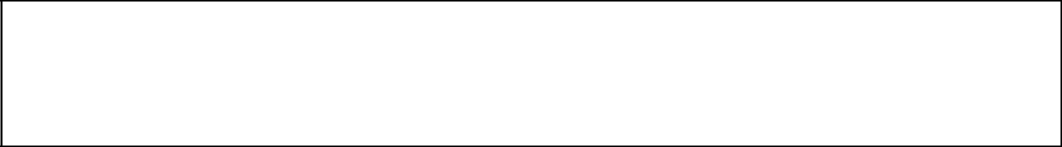

MANAGEMENT REPORT OF THE BOARD OF DIRECTORS

TO THE ANNUAL ORDINARY GENERAL MEETING

ON JUNE 26, 2026

ON THE ANNUAL STATUTORY AND CONSOLIDATED FINANCIAL STATEMENTS

Ladies and Gentlemen,

We have convened this Annual General Meeting in accordance with the law and the Articles of Association, for the purpose, in particular, of presenting a report on the company’s business operations during the fiscal year ended December 31, 2025, and submitting the annual and consolidated financial statements for that fiscal year for your approval.

In addition, the reports of the co-auditors on the annual financial statements and the consolidated financial statements will be read aloud.

I - THE COMPANY’S BUSINESS PERFORMANCE

I.1 - The Company’s Activities During the Past Fiscal Year

Revenue for the year 2025, which for the Company primarily reflects its role in managing and administering the group comprising the Company and its subsidiaries, amounted to 1,329,632 euros, compared to 1,287,273 euros for the 2024 fiscal year.

The Company’s net income resulted in an accounting loss of (3,582,723) euros as of December 31, 2025, compared to an accounting profit of 1,066,614 euros as of December 31, 2024.

Please note that the Group’s consolidated revenue, prepared in accordance with U.S. GAAP and IFRS, amounted to €62.4 million in 2025.

As of December 31, 2025, the Group reported a consolidated net loss of (25.9) million euros in the financial statements prepared in accordance with U.S. GAAP and IFRS.

- An operating loss of (21.9) million euros,

- A net financial loss of (2.8) million euros,

- A negative foreign exchange impact of (0.89) million euros,

- A negative tax impact of (0.39) million euros.

Page 1/10
EDAP TMS SA – Management Report on FY2025 Statutory & Consolidated Accounts

ENGLISH TRANSLATION FOR INFORMATION PURPOSES

I.2 - Changes in the financial position

As of December 31, 2025, the consolidated net cash position stood at €17.4 million.

I.3 – Progress Made or Challenges Encountered

On March 26, 2025, the Focal One Robotic HIFU system received the CE mark, issued by the notified body GMED, for the treatment of deep rectal endometriosis.

On April 24, 2025, the Company announced the launch of the new Focal One i robotic HIFU system, featuring new functionalities.

On July 1, 2025, the Company announced that, effective January 1, 2026, EDAP would become a “U.S. Domestic Filer” and would be required to comply with U.S. SEC reporting rules, like any U.S. company listed in the United States.

On October 20, 2025, the Company announced the conclusion of a €36 million credit facility with the European Investment Bank (EIB). The proceeds from this financing will support development programs for the HIFU Focal One robotic system in the field of focal therapy, while accelerating the launches of new clinical indications. The Company received €11 million as the first tranche of the BSA in the fourth quarter of 2025.

On November 20, 2025, the Company announced that it had received 510(k) clearance from the U.S. Food and Drug Administration (FDA) for new improvements in ultrasound imaging integrated into our Focal One HIFU system.

I.4 - Objective and comprehensive analysis of the Company’s business development, results, and financial position, particularly its debt situation, in light of the volume and complexity of its operations. Key financial performance indicators.

As of December 31, 2025, the holding company has a net financial receivable of €10.9 million from its French subsidiary. There are no particular complexities in the management of its business.

I.5 - Description of the main risks and uncertainties facing the company (financial, social, environmental: existence of pollution, significant debt, loss of profitability, insolvency)

The company’s future growth depends in particular on the implementation of its strategy, which relies heavily on the success of HIFU technology.

Current market trends allow for optimism regarding future sales, thanks in particular to the growth of our installed base, the increase in the number of treatments, HIFU publications, and regulatory progress regarding the treatment of rectal endometriosis using HIFU.

The Company has recorded operating losses in the past and expects these losses to continue for the foreseeable future. As of December 31, 2025, the Company had €17.4 million in cash and cash equivalents, a decrease of €9 million compared to December 31, 2024. The Company intends to draw on Tranche B of its credit facility with the European Investment Bank (“EIB”) in the amount of € 12 million in April 2026, as it believes it meets or will be able to meet all conditions precedent to the drawdown of this second tranche as of the date of publication of these financial statements. With these additional funds, the Company believes it will have sufficient resources to finance its operations for at least a twelve-month period from the date of publication of these consolidated financial statements.

Page 2/10
EDAP TMS SA – Management Report on FY2025 Statutory & Consolidated Accounts

ENGLISH TRANSLATION FOR INFORMATION PURPOSES

However, the Company will need to raise significant additional funds to meet its cash flow needs in the coming period and until it becomes profitable. The Company may be unable to raise additional funds on acceptable terms, or may be unable to raise them at all, which could, in the future, raise uncertainties regarding its ability to continue as a going concern. Management is actively exploring various alternatives, including seeking additional financing in the debt and equity capital markets, cost-cutting measures, and restructuring opportunities, but there is no guarantee that these efforts will succeed or be sufficient to resolve these liquidity issues. If the Company is unable to raise capital on acceptable terms when it needs it, or if it fails to raise any capital at all, it may be forced to restructure its operations or delay, reduce, or terminate its product research and development programs, future commercialization efforts, or other operations.

I.6 - Where relevant to the assessment of its assets, liabilities, financial position, and profit or loss, disclosures regarding its objectives and policies for hedging each major category of forecast transactions for which hedge accounting is used, as well as its exposure to price, credit, liquidity, and cash flow risks. This information must include the company’s use of financial instruments.

NONE

I.7 - The Company’s financial position in light of its debt situation and the volume and complexity of its business, Article L.225-100 of the Commercial Code

On October 17, 2025, we requested the drawdown of Tranche A of the EIB loan and issued 2,624,421 Tranche A stock subscription warrants (BSA) to the EIB. Each Tranche A stock subscription warrant entitles the EIB, upon exercise, to subscribe for one common share. However, the EIB’s exercise of this right will likely result in the future not in the issuance of common shares, but in a net cash payment, the amount of which will be indexed to the average share price over the 90 days preceding the exercise date as well as the euro/dollar exchange rate on that date. At the date of issuance of the warrants, a liability was therefore recognized at their fair value of €4,494k, offset by redemption premiums amortized on a straight-line basis over five years. At the 2025 year-end, this liability was written down to its intrinsic value of €3,386k, with a corresponding entry in the translation adjustment account under liabilities (presented under Other Liabilities). The financing for Tranche A, in the amount of €11.0 million, was disbursed by the EIB in early November 2025. The Tranche A loans will mature five years after the disbursement date. Interest on Tranche A will be payable on the maturity date and will be capitalized annually by increasing the principal of Tranche A. Interest will accrue on Tranche A at a fixed rate of 8% per annum.

In addition, a new loan in the amount of € 367,000 related to the financing of the 2024 CIR was contracted this year for the fiscal year ended 2025, which is in addition to the €329,000 loan related to the financing of the 2023 CIR that had been contracted by the company for the fiscal year ended December 31, 2024.

I.8 - Significant events since the end of the fiscal year

NONE

I.9 - Forecast and Outlook

As a holding company, we refer you to our comments below regarding the “Group’s future outlook and trends.” II - PRESENTATION OF THE ANNUAL FINANCIAL STATEMENTS - APPROPRIATION OF EARNINGS

The accounting presentation rules comply with current regulations and are identical to those of the previous fiscal year. You will find all additional explanations in the notes.

Page 3/10
EDAP TMS SA – Management Report on FY2025 Statutory & Consolidated Accounts

ENGLISH TRANSLATION FOR INFORMATION PURPOSES

The figures as of December 31, 2025, are as follows:

 |  |  | ​​​ |  | 12/31/2025 | ​​​ |  |  | 12/31/2024
 | · | Revenue amounts to |  | € | 1,329,632 |  |  | € | 1,287,273
 | · | Total operating revenue amounts to | € |  | 1,458,833 |  | € |  | 1,756,358
 | · | Total operating expenses amount to |  | € | 4,314,798 |  |  | € | 4,028,958
 | Resulting in an operating profit of |  |  | € | (2,855,965) |  |  |  | (2,272,600)
 | · | Total financial income amounts to | € |  | 1,288,723 |  | € |  | 3,763,436
 | · | Total financial expenses amount to |  | € | 2,015,481 |  |  | € | 424,222
 | Resulting in a financial result of |  |  | € | (726,758) |  |  | € | 3,339,214
 | · | The pre-tax operating income is therefore | € |  | (3,582,723) |  | € |  | 1,066,614
 | · | Total extraordinary income amounts to |  | € | 0 |  |  | € | 0
 | · | Total extraordinary expenses amount to |  | € | 0 |  |  | € | 0
 | Resulting in an extraordinary result of |  |  | € | 0 |  |  | € | 0
 | Income tax |  |  | € | 0 |  |  | € | 0
 | · | Net income (Loss) of |  | € | (3,582,723) |  |  | € | 1,066,614

Based on this result, the equity of the holding company EDAP TMS SA amounts to €93,521,693 for a share capital of €4,907,697 as of December 31, 2025.

III – PROPOSAL FOR THE APPROPRIATION OF THE RESULT FOR THE PAST FISCAL YEAR

The balance sheet of the holding company EDAP TMS SA as of 12/31/2025 shows an accounting loss of (3,582,723) euros.

Consequently, we propose to allocate the entire amount to the “retained earnings” debit account in the amount of (3,582,723) euros, thereby increasing the balance from (15,696,866) euros to (19,279,590) euros.

IV - NON-TAX-DEDUCTIBLE EXPENSES AND CHARGES

In accordance with the provisions of Article 223 quater of the General Tax Code, we ask that you note that no expenses or charges referred to in Article 39-4 of this Code, nor any amount of theoretical tax, will be borne by the company.

V - AMOUNT OF DIVIDENDS DISTRIBUTED FOR THE PREVIOUS THREE FISCAL YEARS

In accordance with the provisions of Article 243 bis of the General Tax Code, we draw your attention to the fact that no dividends were paid for the three preceding fiscal years.

VI - TABLE OF THE COMPANY’S FINANCIAL RESULTS

Attached to this report is a table showing the company’s results for the past fiscal year and the five preceding fiscal years.

Page 4/10
EDAP TMS SA – Management Report on FY2025 Statutory & Consolidated Accounts

ENGLISH TRANSLATION FOR INFORMATION PURPOSES

VII – INFORMATION ON THE BREAKDOWN OF ACCOUNTS PAYABLE/RECEIVABLE BALANCES BY DUE DATE

In accordance with the provisions of the Commercial Code, we provide, in the Appendix to this report, a breakdown—in accordance with the templates established by the decree of March 20, 2017—of the payment terms for our suppliers and customers, showing:

- invoices received and issued that remain unpaid as of the fiscal year-end and for which the payment term has expired.

Please refer to Appendix 1, which contains the table of customer/supplier payment terms.

VIII - Subsidiaries and Equity Interests

EDAP TMS France SAS:

This wholly-owned subsidiary encompasses the Development, Production, and Services activities for both product lines: HIFU and lithotripsy, as well as sales outside areas covered by other distribution subsidiaries.

In 2025, it generated net revenue of €30.3 million compared to €33.7 million in 2024, and reported a net loss of (4,089,039) euros in 2025 compared to a loss of (3,229,001) euros in 2024.

It is noted that EDAP TMS France SAS holds 100% of the capital of (i) EDAP TMS GmbH, the distribution subsidiary for Germany, and (ii) EDAP Switzerland GmbH, established on May 3, 2024, responsible for marketing EDAP TMS Group products in Switzerland.

We also remind you that EDAP TMS France SAS has an additional establishment in South Korea.

EDAP TECHNOMED Co. Ltd (Tokyo, Japan):

This wholly-owned subsidiary, responsible for distributing the Group’s products in Japan, generated revenue of €10.7 million in 2025 compared to €12.5 million in 2024 and a net loss of €0.9 million in 2025 compared to a net profit of €58,000 in 2024.

EDAP TECHNOMED Inc. (Austin, TX, U.S.A.):

This wholly owned subsidiary, responsible for the commercial development of the company’s operations in the United States, generated revenue of €25.3 million in 2025, compared with €18.4 million in 2024, and reported a net loss of (14.31) in 2025, compared to a net loss of (14.43) million in 2024.

EDAP TECHNOMED Sdn Bhd (Petaling Jaya):

This wholly-owned subsidiary, responsible for distributing the Group’s products in Southeast Asia and the the Pacific (excluding Korea and Japan), generated revenue of € 4.8 million in 2025 compared to €4.6 million in 2024 and a net profit of €1,120 in 2025 compared to a net profit of €806,000 in 2024.

IX – RESEARCH AND DEVELOPMENT ACTIVITIES

As a holding company, EDAP TMS SA does not engage in R&D activities.

Page 5/10
EDAP TMS SA – Management Report on FY2025 Statutory & Consolidated Accounts

ENGLISH TRANSLATION FOR INFORMATION PURPOSES

X – REGULATED AGREEMENTS

We ask you, in accordance with Article L. 225-40 of the French Commercial Code, to approve, in a first resolution, the special report of the statutory auditor stating the absence of any agreement referred to in Article L. 225-38 of the French Commercial Code.

XI – GROUP OUTLOOK AND TRENDS

To date, our overall strategy is to expand our HIFU business in the United States and globally to accelerate the adoption of Focal One Robotic HIFU. We are focusing our efforts on the clinical development and commercialization of our HIFU products, with the aim of expanding clinical indications beyond prostate cancer. Going forward, we intend to concentrate the majority of our investments and resources on our HIFU business, while scaling back our activities related to lithotripsy and distribution.

XII – DIRECTORS’ PERFORMANCE-BASED COMPENSATION

The amount of 244,410 euros was paid to the directors as compensation for their services for the year 2025.

XIII - STATUS OF THE APPOINTMENTS OF THE REGULAR AUDITORS AND THE ASSISTANT AUDITOR

We remind you that the term of office of the incumbent auditors is held by the firm KPMG SA, located at 2, Avenue Gambetta, Tour Eqho, 92066 Paris la Défense CEDEX, registered with the Nanterre Trade and Companies Register under number 775726417, for a period of six fiscal years beginning on January 1January 2024. KPMG SA’s term of office will end following the General Meeting called to approve the financial statements for the fiscal year ending December 31, 2029, i.e., in 2030.

In addition, the role of the company’s co-statutory auditor has been held since June 30, 2020—the date of its appointment—by the firm AGILI3F, located at 69 boulevard des Canuts, 69004 Lyon, RCS Lyon 840 062 442, for a term of six fiscal years ending at the close of the ordinary general meeting called to approve the financial statements for the fiscal year ending December 31, 2025, i.e., in June 2026. The renewal of the term of office of the co-statutory auditor AGILI3F will be submitted for approval by the shareholders at the annual general meeting approving the financial statements for the fiscal year ending December 31, 2025, scheduled for June 26, 2026.

XIV – STATEMENT OF EMPLOYEE OWNERSHIP IN THE SHARE CAPITAL AS OF DECEMBER 31, 2025

In accordance with the provisions of Article L.225-102 of the French Commercial Code, we hereby report on the status of employee ownership in the Company’s share capital as of the last day of the fiscal year, December 31, 2025.

The employees’ share of the share capital was less than 1% as of December 31, 2025.

Furthermore, no portion of the capital is represented by shares held by the Company’s employees under a corporate savings plan provided for in Articles L. 3332-1 et seq. of the Labor Code, or by employees or former employees through corporate mutual funds.

XV – TREASURY SHARES AND VOTING RIGHTS

As of December 31, 2025, the Company held 269,533 treasury shares with a gross book value of 590,427 euros. We confirm that the Company did not make any acquisitions during the fiscal year.

The number of voting shares as of December 31, 2025, is 37,442,155.

Page 6/10
EDAP TMS SA – Management Report on FY2025 Statutory & Consolidated Accounts

ENGLISH TRANSLATION FOR INFORMATION PURPOSES

XVI - ACQUISITION OF SIGNIFICANT INTERESTS IN FRANCE OR ACQUISITION OF CONTROL

In accordance with the provisions of the first paragraph of Article L.233-6 of the French Commercial Code, we hereby inform you that our Company did not, during the past fiscal year, acquire any new equity interest in a company having its registered office within the territory of the French Republic.

XVII - CROSS-SHAREHOLDINGS

We hereby inform you that we hold no equity interest in any company that is a shareholder of our Company and that, consequently, the review of cross-shareholdings is not applicable.

XIII - ADJUSTMENT OF STOCK OPTIONS AND SECURITIES GIVING FUTURE ACCESS TO THE SHARE CAPITAL

Pursuant to Article R. 228-91, we hereby inform you that there were no adjustments to stock subscription or purchase options or securities giving future access to the share capital issued by the Company during the 2024 fiscal year.

XIX - DECISION BY THE COMPETITION AUTHORITY REGARDING ANTICOMPETITIVE PRACTICES

NONE

XX - INFORMATION ON THE AMOUNT OF LOANS GRANTED BY THE COMPANY

NONE

XXI - FEES PAID TO THE STATUTORY AUDITORS

For the fiscal year ended December 31, 2025, the amount of fees paid to the auditors totals 547,070.00 Euros excluding tax.

In accordance with Article L 820-3, paragraph 1, of the Commercial Code, we hereby inform you that the firm KPMG S.A., the statutory auditor, is a member of a network and that this network has billed for services other than those related to the audit of the financial statements.

AGILI3F is also a statutory auditor and has billed only for services related to the audit of the financial statements. This information is available to shareholders at the Company’s headquarters.

XXII - PRESENTATION OF THE CONSOLIDATED FINANCIAL STATEMENTS (in accordance with IFRS)

The accounting presentation rules comply with current regulations.

You will find all additional explanations in the notes—IFRS report.

Page 7/10
EDAP TMS SA – Management Report on FY2025 Statutory & Consolidated Accounts

 | ENGLISH TRANSLATION FOR INFORMATION PURPOSES
The figures as of December 31, 2025, are as follows (in thousands of euros):
 |  | ​​​ 2025 |  | ​​​ 2024
 | Sales of goods |  | 43,273 |  | 44,037
 | Sales of Revenue-per-Procedure (RPPs) and leases | 9,106 |  | 7,610
 | Sales of spare parts and services | 10,037 |  | 12,468
 | Total Revenue |  | 62,416 |  | 64,114
 | Cost of goods | (24,027) |  | (24,599)
 | Cost of RPPs and leases | (5,525) |  | (4,964)
 | Cost of spare parts and services | (6,313) |  | (7,996)
 | Total cost of sales |  | (35,865) |  | (37,558)
 | Gross Margin |  | 26,551 |  | 26,556
 | Research and Development (R&D) Expenses | (8,550) |  | (7,726)
 | Sales and marketing expenses | (24,174) |  | (25,281)
 | Administrative and General Expenses | (15,682) |  | (14,083)
 | Operating income |  | (21,854) |  | (20,534)
 | Net financial income | (2,753) |  | 560
 | Foreign exchange gain (loss), net | (888) |  | 1,246
 | Income before tax |  | (25,495) |  | (18,729)
 | Income tax | (388) |  | (289)
 | Net income |  | (25,883) |  | (19,018)
Basic net income per share
 |  |  | (0.69) |  | (0.51)
 | Diluted net income per share | (0.69) |  | (0.51)
 | Weighted average number of common shares outstanding | 37,442,155 |  | 37,286,446
 | Weighted-average diluted number of common shares outstanding | 37,442,155 |  | 37,286,446

XXIII – AMENDMENTS TO THE BYLAWS

NONE

* * *

We thank you for the confidence you will show in us by adopting the proposed resolutions.

THE BOARD OF DIRECTORS

(on March 24, 2026)

Page 8/10
EDAP TMS SA – Management Report on FY2025 Statutory & Consolidated Accounts

ENGLISH TRANSLATION FOR INFORMATION PURPOSES

RESULTS FOR THE LAST FIVE FISCAL YEARS (In Euros)

FISCAL YEAR END | 12/31/21 | 12/31/22 | 12/31/23 | 12/31/24 | 12/31/25
Fiscal year | 12 months | 12 months | 12 months | 12 months | 12 months
Financial position at year-end
Share capital | 4,388,613 | 4,835,705 | 4,858,531 | 4,896,010 | 4,907,697
Number of shares issued | 33,758,564 | 37,197,731 | 37,373,312 | 37,661,619 | 37,751,519
Number of bonds convertible into shares
Total income from actual operations
Revenue excluding taxes | 830,941 | 925,146 | 914,752 | 1,287,273 | 1,329,632
Income before taxes, Employee profit
sharing, depreciation, and provisions | 888,567 | 750,320 | (2,363,885) | 1,066,614 | (3,409,406)
Income taxes | 83,319 | (283,360) | (3,074) | 0 | 0
Employee Participation
Earnings after taxes, depreciation, and
provisions | 805,248 | 1,038,067 | (2,366,869) | 1,066,614 | (3,409,406)
Amount of dividends distributed | 0 | 0 | 0 | 0 | 0
Earnings per share
Earnings after taxes, but before
depreciation, amortization, and
provisions, | 0(*) | 0(*) | 0(*) | 0(*) | 0(*)
Earnings after taxes, depreciation, and
provisions | 0 | 0 | 0 | 0 | 0
Dividend paid per share | 0 | 0 | 0 | 0 | 0
STAFF
Number of employees | 4 | 4 | 3 | 3 | 3
Total payroll | 443,807 | 590,388 | 364,760 | 529,268 | 510,920
Amount paid for employee benefits
(social security, social welfare programs,
etc.) | 325,984 | 426,613 | 346,739 | 300,581 | 251,720

(*) Given the losses incurred during the fiscal year, no earnings per share were reported.

Page 9/10
EDAP TMS SA – Management Report on FY2025 Statutory & Consolidated Accounts

ENGLISH TRANSLATION FOR INFORMATION PURPOSES

APPENDIX 1

(EDAP TMS S.A. Management Report 2024)

TABLE OF PAYMENT TERMS

Invoices received and issued that were unpaid as of the fiscal year-end and for which the payment term has expired (table provided for in

Section I of Article D. 441-4)

 |  | Article D441-I.-1°: Received invoices outstanding as of the fiscal year-end |  |  |  |  |  |  |  |  | Article D441-I.-1°: Issued invoices outstanding as of the fiscal year-end and
 |  |  |  |  | whose | payment terms have expired |  |  |  |  |  |  |  |  | past due
 |  |  | 1 to 30 | 31 to 60 |  |  | 61 to 90 | + 91 days | TOTAL |  | 1 to 30 | 31 to 60 |  |  | 61 to 90 | + 91 days | TOTAL
 |  |  | days | d days |  |  | days |  |  |  | days | days |  |  | days
 | By payment delay brackets
 |  |  |  |  |  |  |  |  | 20 |  |  |  |  |  |  |  | 25
 | Number of
 | invoices
 | affected
 | Total |  | €317,357 | €1,200 |  |  | €184,480 | €2,475,408 | €2,978,445 |  | €0 |  | €0 |  | €352,047 | €2,032,203 | €2,384,250
 | amount of
 | affected
 | invoices
 | Including
 | tax
 | Percentage |  | 10.55% | 0.04% |  |  | 6.13% | 82.27% | 98.99%
 | of total
 | purchases
 | for the
 | fiscal year
 | Including
 | tax
 | Percentage |  |  |  |  |  |  |  |  |  | 0% | 0% |  |  | 24.19% | 139.61% | 163.80%
 | of revenue
 | for the
 | fiscal year
 | Including
 | tax
 | B Invoices excluded from (A) relating to disputed or unrecorded debts and receivables
 | Number of | None |  |  |  |  |  |  |  | None
 | invoices
 | excluded
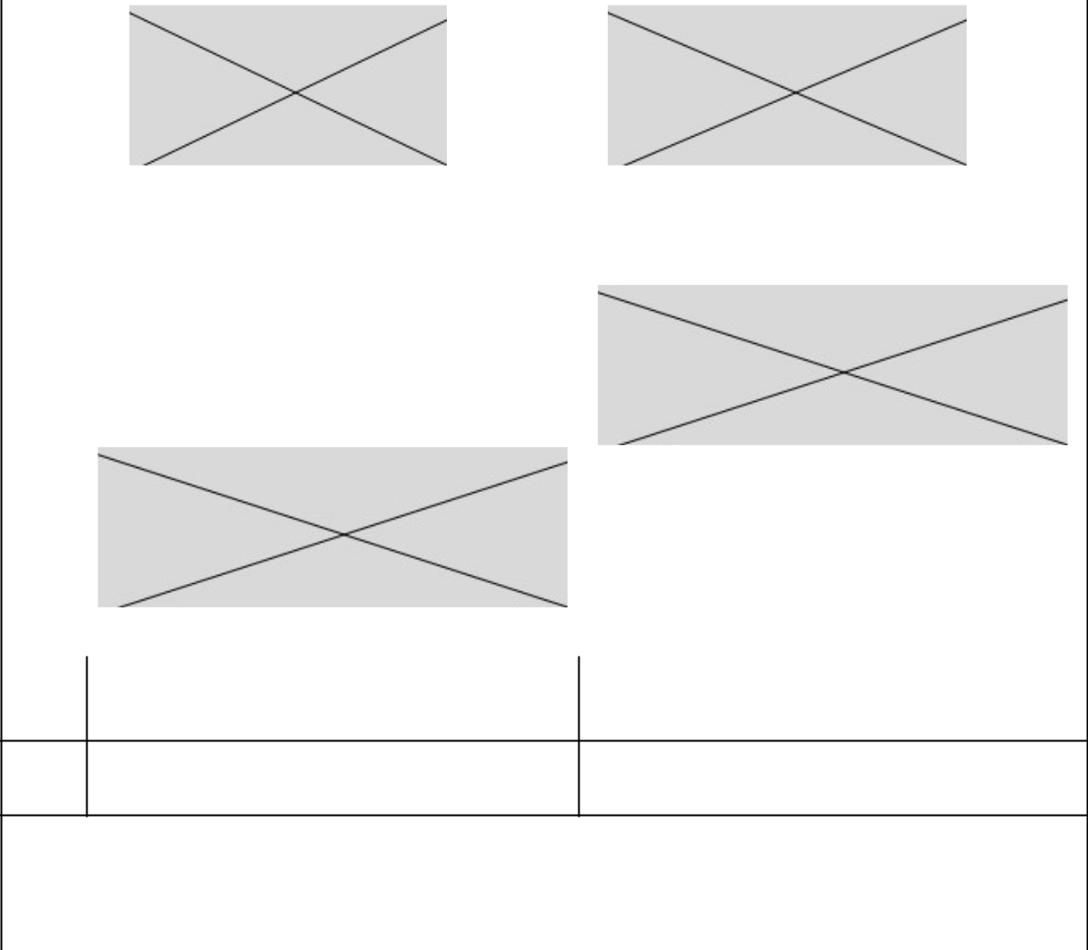

Total
amount of
excluded
invoices

C Reference payment terms used (contractual or statutory—Article L441-6 or Article L443-1 of the Commercial Code)

Payment | Contractual terms: Between 30 and 60 days | Contractual terms: 60 days on average
terms used
to calculate
late | Statutory terms: | Statutory terms:
payments | Statutory terms: | Statutory terms:

Page 10/10
EDAP TMS SA – Management Report on FY2025 Statutory & Consolidated Accounts

