UNITED STATES
SECURITIES AND EXCHANGE COMMISSION
WASHINGTON, D.C. 20549

FORM 8-K

CURRENT REPORT

Pursuant to Section 13 or 15(d) of the
Securities Exchange Act of 1934

Date of Report (Date of earliest event reported): August 11, 2026

EDAP TMS S.A.
(Exact name of Registrant as specified in its charter)

France | 000-29374 | 98-1644844
(State or other jurisdiction  of incorporation) | (Commission File No.) | (I.R.S. Employer  Identification No.)

Parc d’Activites la Poudrette-Lamartine
4/6, rue du Dauphiné
Vaulx-en-Velin, France 69120
(Address of Principal Executive Offices) (Zip Code)

Registrant’s telephone number, including area code: (+33) 47-215-3150

Not Applicable
(Former name or former address if changed since last report)

Check the appropriate box below if the Form 8-K filing is intended to simultaneously satisfy the filing obligation of the registrant under any of the following provisions:

☐ | Written communications pursuant to Rule 425 under the Securities Act (17 CFR 230.425)

☐ | Soliciting material pursuant to Rule 14a-12 under the Exchange Act (17 CFR 240.14a-12)

☐ | Pre-commencement communications pursuant to Rule 14d-2(b) under the Exchange Act (17 CFR 240.14d-2(b))

☐ | Pre-commencement communications pursuant to Rule 13e-4(c) under the Exchange Act (17 CFR 240.13e-4(c))

Securities registered pursuant to Section 12(b) of the Act:

Title of Each Class | Trading Symbol(s) | Name of Each Exchange on Which Registered
American Depositary Shares, each representing one Ordinary Share (Ordinary Shares, nominal value €0.13 per share) | FOCL | NASDAQ Global Market

Indicated by check mark whether the registrant is an emerging growth company as defined in Rule 405 of the Securities Act of 1933 (§230.405 of this chapter) or Rule 12b-2 of the Securities Exchange Act of 1934 (§240.12b-2 of this chapter).
Emerging Growth Company | ☐

If an emerging growth company, indicate by check mark if the registrant has elected not to use the extended transition period for complying with any new or revised financial accounting standards provided pursuant to Section 13(a) of the Exchange Act. ☐

 | Item 2.02 | Results of Operations and Financial Condition.

On August 11, 2026, EDAP TMS S.A. (the “Company”) announced certain preliminary unaudited estimated financial results as of and for the six months ended June 30, 2026. This announcement was contained in a press release (the “Press Release”), a copy of which is attached as Exhibit 99.1 hereto. Such exhibit and the information set forth therein shall not be deemed to be filed for purposes of Section 18 of the Securities Exchange Act of 1934, as amended (the “Exchange Act”), or otherwise be subject to the liabilities of that section, nor shall it be deemed to be incorporated by reference in any filing under the Securities Act of 1933, as amended, or the Exchange Act.

The information set forth under Item 8.01 of this Current Report on Form 8-K is incorporated by reference in this Item 2.02.

 | Item 7.01 | Regulation FD Disclosure.

The information set forth in Item 2.02 of this Current Report on Form 8-K pertaining to the Press Release is incorporated herein by reference.

 | Item 8.01 | Other Events.

On August 11, 2026, the Company made a presentation (the “Investor Presentation”) available on the “Investors” section of its website at www.focalone.com. The Investor Presentation is filed as Exhibit 99.2 hereto and is incorporated herein by reference.

Expansion into New Indications

Expansion into Benign Prostatic Hyperplasia (BPH)

The Company is advancing the evaluation of its Focal One Robotic HIFU platform for the potential treatment of benign prostatic hyperplasia ("BPH"). Based on published third-party estimates, more than 100 million men worldwide are living with BPH, with more than 13 million new cases diagnosed annually including over 600,000 in the United States. The Company believes its experience in robotic HIFU for prostate cancer may provide a foundation for developing a non-invasive treatment option for patients with BPH. The Company’s BPH development program is currently focused on feasibility studies inside and outside the United States. In the United States, the feasibility study has received Institutional Review Board approval. Outside the United States, a multicenter feasibility study is underway.

Focal One has not been cleared or approved by the U.S. Food and Drug Administration (the "FDA") or any other regulatory authority for the treatment of BPH, and its use for that indication is investigational. There can be no assurance that the Company’s BPH development program will be successful or that Focal One will receive regulatory clearance or approval for this indication.

Expansion into Endometriosis

The Company is also advancing development of the Focal One Robotic HIFU platform for the potential treatment of deep infiltrating endometriosis, a severe form of endometriosis for which treatment options are currently limited primarily to hormonal therapy and surgery. Based on published third-party estimates, approximately 38 million women worldwide are affected by deep infiltrating endometriosis, with more than 783,000 patients diagnosed annually including over 225,000 in the United States. The Company believes its robotic HIFU technology may provide a non-invasive treatment alternative, as opposed to current treatment options that are limited to hormone therapy and/or invasive surgery, designed to reduce symptoms and improve quality of life. Outside the United States, the Company’s endometriosis program is progressing through ongoing clinical development, including a randomized controlled pivotal study, and the Company has initiated a limited commercial launch in Europe under its CE mark for this indication. In the United States, the Company received FDA Breakthrough Device Designation for this indication in 2024 and is evaluating long-term data generated from its European studies to inform its regulatory strategy.

Focal One has not been cleared or approved by the FDA for the treatment of deep infiltrating endometriosis, and its use for that indication in the United States is investigational. Breakthrough Device Designation provides for enhanced interaction with the FDA during development and review but does not guarantee or accelerate clearance or approval, and there can be no assurance that Focal One will receive clearance or approval for this indication.

Cautionary Statement on Forward-Looking Statements

In addition to historical information, this Current Report on Form 8-K contains forward-looking statements within the meaning of applicable federal securities laws, including Section 27A of the U.S. Securities Act of 1933 (the “Securities Act”) or Section 21E of the U.S. Securities Exchange Act of 1934, as amended, including the information contained in the Press Release, the information contained in the Investor Presentation and the information concerning the new indications, which may be identified by words such as “believe,” “can,” “contemplate,” “could,” “plan,” “intend,” “is designed to,” “may,” “might,” “potential,” “objective,” “target,” “project,” “predict,” “forecast,” “ambition,” “guideline,” “should,” “will,” “estimate,” “expect” and “anticipate,” or the negative of these and similar expressions, which reflect the Company’s views about future events and financial performance. Such statements are based on management's current expectations and are subject to a number of risks and uncertainties, including matters not yet known to the Company or not currently considered material by the Company, and there can be no assurance that anticipated events will occur or that the objectives set out will actually be achieved. Important factors that could cause actual results to differ materially from the results anticipated in the forward-looking statements include, but are not limited to, uncertainties related to market conditions and those risks relating to the Company’s business, which are described in the Company’s filings with the SEC and in particular in the section “Risk Factors” in the Company's Annual Report on Form 10-K and Quarterly Report on Form 10-Q.

Forward-looking statements speak only as of the date they are made. Other than required by law, the Company does not undertake any obligation to update them in light of new information or future developments. These forward-looking statements are based upon information, assumptions and estimates available to the Company as of the date of this Current Report on Form 8-K, and while the Company believes such information forms a reasonable basis for such statements, such information may be limited or incomplete.

 | Item 9.01 | Financial Statements and Exhibits.

(d) Exhibits

Exhibit No. |  | Description
99.1 |  | Press Release, dated August 11, 2026
99.2 |  | Investor Presentation, dated August 11, 2026
104 |  | Cover Page Interactive Data File-the cover page XBRL (embedded within the Inline XBRL document)

SIGNATURES

Pursuant to the requirements of the Securities Exchange Act of 1934, the registrant has duly caused this report to be signed on its behalf by the undersigned hereunto duly authorized.

 | EDAP TMS S.A.
Date: August 11, 2026 | By: | /s/ Sanket Shah
 |  | Sanket Shah
 |  | General Counsel and Corporate Secretary

Exhibit 99.1

FocalTherics™ Reports Preliminary Financial Results for Second Quarter of 2026

AUSTIN, Texas, August 11, 2026 - FocalTherics™ (Nasdaq: FOCL) (the “Company”), a global leader in robotic focal therapy, today announced preliminary unaudited financial results for the Company’s HIFU segment, reported as continuing operations, for the second quarter of 2026.

During the second quarter of 2026, the Extracorporeal Shock Wave Lithotripsy (ESWL) and Distribution segments met the criteria to be classified as held for sale under ASC 205-20, Presentation of Financial Statements — Discontinued Operations, and ASC 360-10, Property, Plant, and Equipment, and the Company determined that the planned exit represents a strategic shift that will have a significant effect on the Company’s operations and financial results. Accordingly, the Company’s unaudited financial results as of and for the three and six months ended June 30, 2026 reflect the Company’s ESWL and Distribution operating segments as discontinued operations. The following reflect the Company’s continuing operations (the Company’s HIFU segment) for the second quarter of 2026:

 | • | Revenue Between $12.7 and $13.2 million, Representing an Increase Between 34% and 39% from the Three Months Ended June 30, 2025

 | • | Gross Margin Between 54% and 56%, Representing an Increase Between 3% and 5% from the Three Months Ended June 30, 2025

In addition, the Company reported cash, cash equivalents and short-term investments from all operations of $21.5 million as of June 30, 2026.

All figures reported above with respect to the second quarter of 2026 and as of June 30, 2026, are preliminary and are unaudited and subject to change and adjustment as the Company prepares its unaudited interim condensed consolidated financial statements for the three- and six-month periods ended June 30, 2026 and 2025. Accordingly, investors are cautioned not to place undue reliance on the foregoing information. The Company does not intend to provide preliminary results in the future. The preliminary results provided in this news release constitute “forward-looking information” and “forward-looking statements” within the meaning of U.S. securities laws, are based on several assumptions and are subject to a number of risks and uncertainties. Actual results may differ materially. See “Forward-looking Statements.”

The Company intends to report full second quarter of 2026 financial results after market close on Thursday, August 13th and will hold a conference call at 4:30 pm ET that day to discuss results.

About FocalTherics

A recognized global leader in robotic focal therapy, FocalTherics develops, manufactures, and markets minimally invasive medical devices worldwide to treat various conditions using proprietary focused ultrasound technology. The Company’s flagship platform, Focal One Robotic HIFU, combines advanced imaging, real-time treatment planning, robotic precision, and HIFU technology to deliver personalized focal therapy designed to optimize clinical outcomes while preserving quality of life.

Forward-Looking Statements

In addition to historical information, this press release contains forward-looking statements within the meaning of applicable federal securities laws, including Section 27A of the U.S. Securities Act of 1933 (the “Securities Act”) or Section 21E of the U.S. Securities Exchange Act of 1934, which may be identified by words such as “believe,” “can,” “contemplate,” “could,” “plan,” “intend,” “is designed to,” “may,” “might,” “potential,” “objective,” “target,” “project,” “predict,” “forecast,” “ambition,” “guideline,” “should,” “will,” “estimate,” “expect” and “anticipate,” or the negative of these and similar expressions, which reflect the Company’s views about future events and financial performance. Such statements are based on management's current expectations and are subject to a number of risks and uncertainties, including matters not yet known to the Company or not currently considered material by the Company, and there can be no assurance that anticipated events will occur or that the objectives set out will actually be achieved, and include statements such as the expected financial results for the three months ended June 30, 2026 and as of June 30, 2026. Important factors that could cause actual results to differ materially from the results anticipated in the forward-looking statements include, among others, the clinical status and market acceptance of the Company’s HIFU devices and the continued market potential for the Company’s ESWL and Distribution divisions, as well as risks associated with the current worldwide inflationary environment, the uncertain worldwide economic, political and financial environment, geopolitical instability, climate change and pandemics, or other public health crises, and their related impact on the Company’s business operations, including their impacts across the Company’s businesses or demand for its devices and services.

Other factors that may cause such a difference may also include, but are not limited to, those described in the Company's filings with the Securities and Exchange Commission and in particular, in the sections "Cautionary Statement on Forward-Looking Information" and "Risk Factors" in the Company's Annual Report on Form 10-K and Quarterly Report on Form 10-Q.

Forward-looking statements speak only as of the date they are made. Other than required by law, the Company does not undertake any obligation to update them in light of new information or future developments. These forward-looking statements are based upon information, assumptions and estimates available to the Company as of the date of this press release, and while the Company believes such information forms a reasonable basis for such statements, such information may be limited or incomplete.

Investor Contact
Louisa Smith
Gilmartin Group
investor.relations@focalone.com

Exhibit 99.2
 | 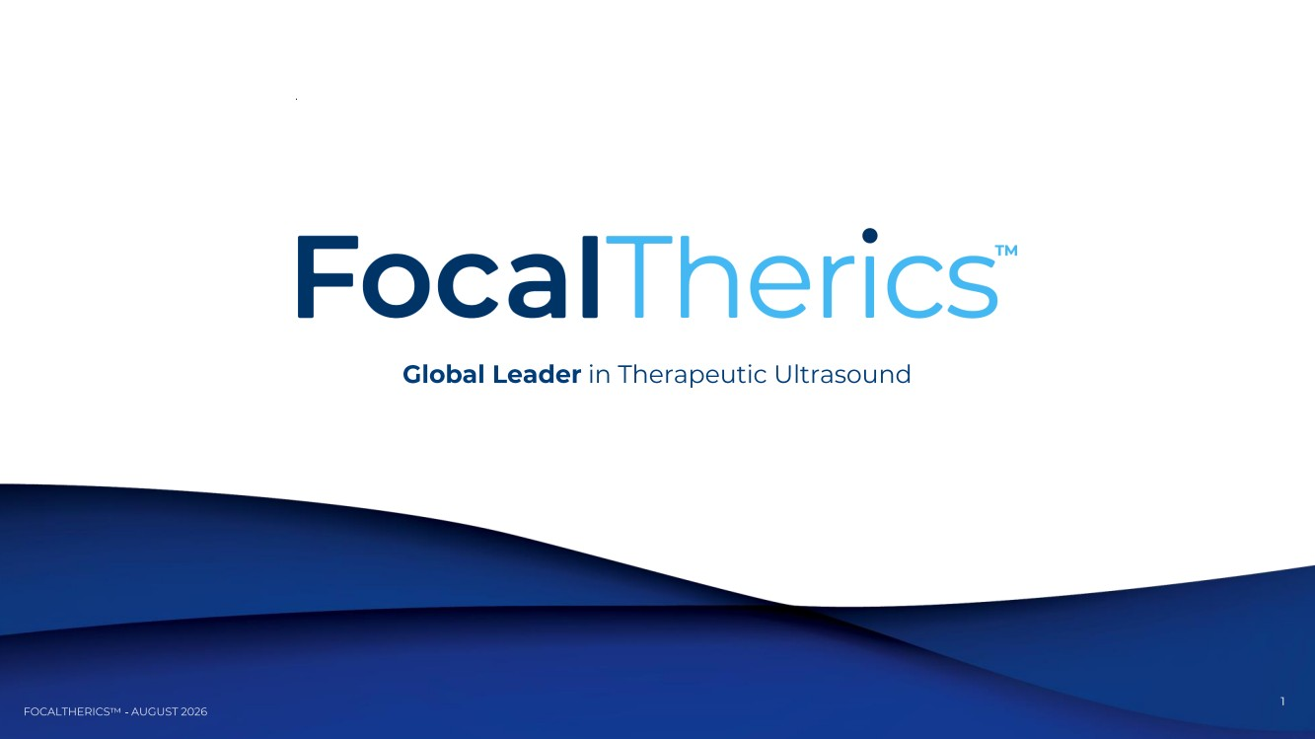 | 1 Global Leader in Therapeutic Ultrasound
 |  | 2 Statements & Disclaimer
 |  | 3 • Rebranded to FocalTherics (NASDAQ: FOCL) • Executed Successful NASDAQ MarketSite Investor Day on June 1 • Announced Core Focus on High -Growth Robotic Focal Therapy • Shift of Reporting Legacy Non -Core ESWL and Distribution Financials To Discontinued Operations Effective Q2'26
 |  | 4 Global Leader in Therapeutic Ultrasound Redefining the Treatment of Cancer and Benign Disease through Organ Sparing, Function Preserving Focal Therapy
 | 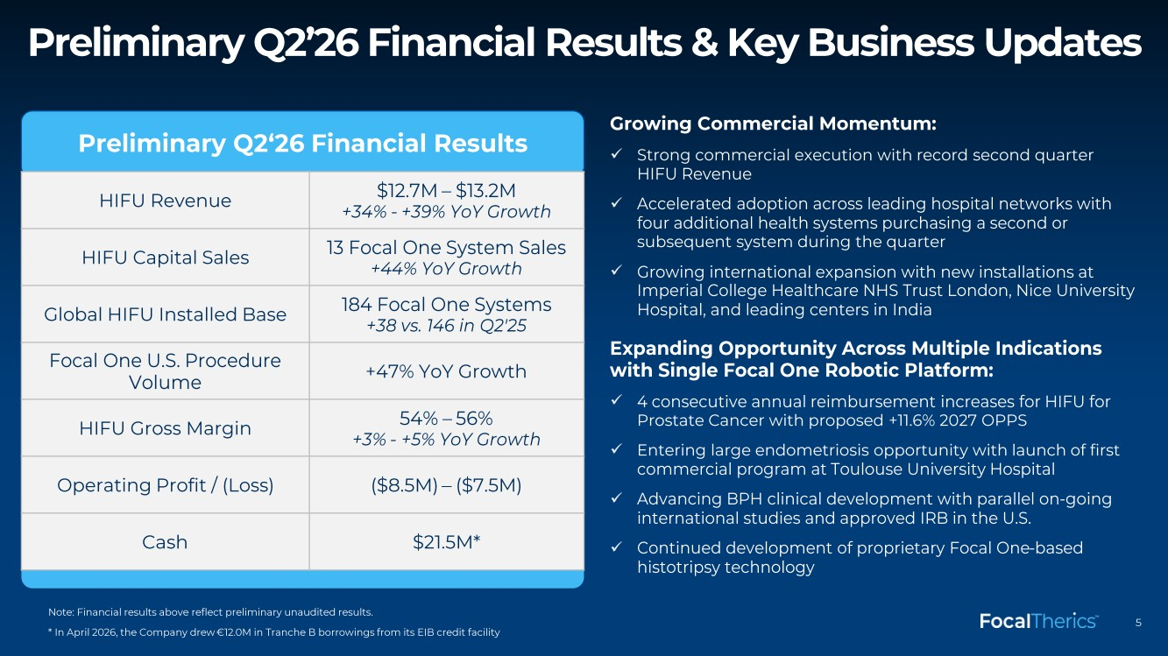 | 5 Preliminary Q2’26 Financial Results & Key Business Updates Growing Commercial Momentum: ✓ Strong commercial execution with record second quarter HIFU Revenue ✓ Accelerated adoption across leading hospital networks with four additional health systems purchasing a second or subsequent system during the quarter ✓ Growing international expansion with new installations at Imperial College Healthcare NHS Trust London, Nice University Hospital, and leading centers in India Expanding Opportunity Across Multiple Indications with Single Focal One Robotic Platform: ✓ 4 consecutive annual reimbursement increases for HIFU for Prostate Cancer with proposed +11.6% 2027 OPPS ✓ Entering large endometriosis opportunity with launch of first commercial program at Toulouse University Hospital ✓ Advancing BPH clinical development with parallel on -going international studies and approved IRB in the U.S. ✓ Continued development of proprietary Focal One -based histotripsy technology Preliminary Q2‘26 Financial Results HIFU Revenue $12.7M – $13.2M +34% - +39% YoY Growth HIFU Capital Sales 13 Focal One System Sales +44% YoY Growth Global HIFU Installed Base 184 Focal One Systems +38 vs. 146 in Q2'25 Focal One U.S. Procedure Volume +47% YoY Growth HIFU Gross Margin 54% – 56% +3% - +5% YoY Growth Operating Profit / (Loss) ($8.5M) – ($7.5M) Cash $21.5M* Note: Financial results above reflect preliminary unaudited results. * In April 2026, the Company drew €12.0M in Tranche B borrowings from its EIB credit facility
 |  | 6 Large and Growing Market Opportunities In Prostate Cancer, BPH and Endometriosis
 | 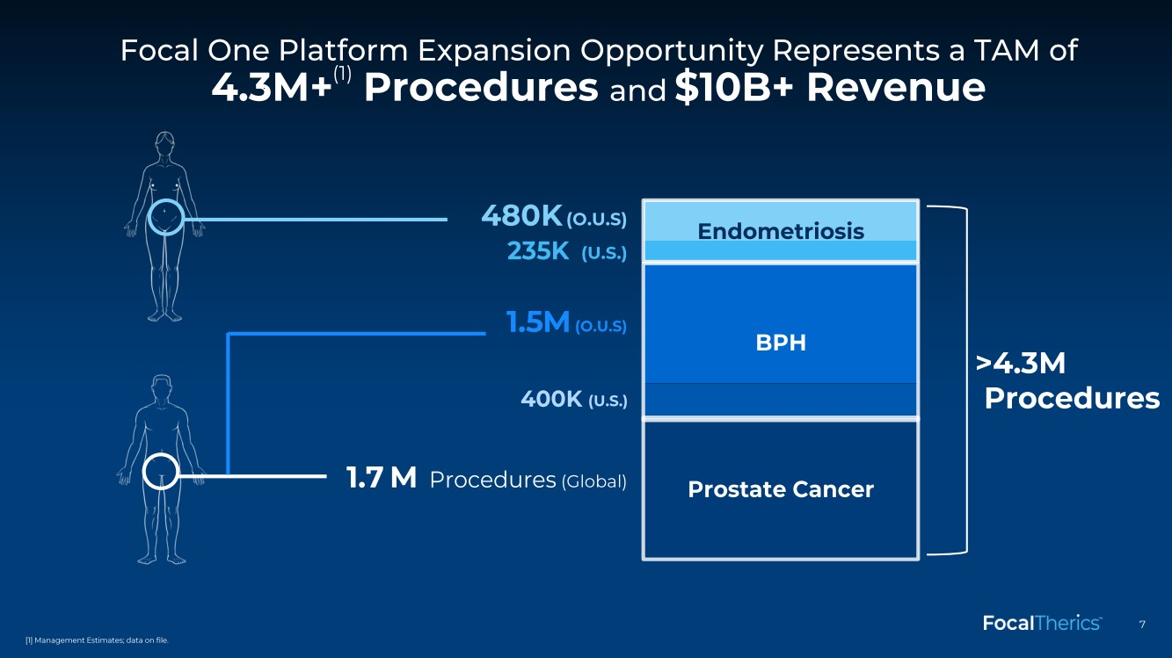 | 7 1.5M (O.U.S) 400K (U.S.) 235K (U.S.) 480K (O.U.S) Focal One Platform Expansion Opportunity Represents a TAM of 4.3M+ (1) Procedures and $10B+ Revenue >4.3M Procedures 1.7 M Procedures (Global) Prostate Cancer BPH Endometriosis [1] Management Estimates; data on file.
 | 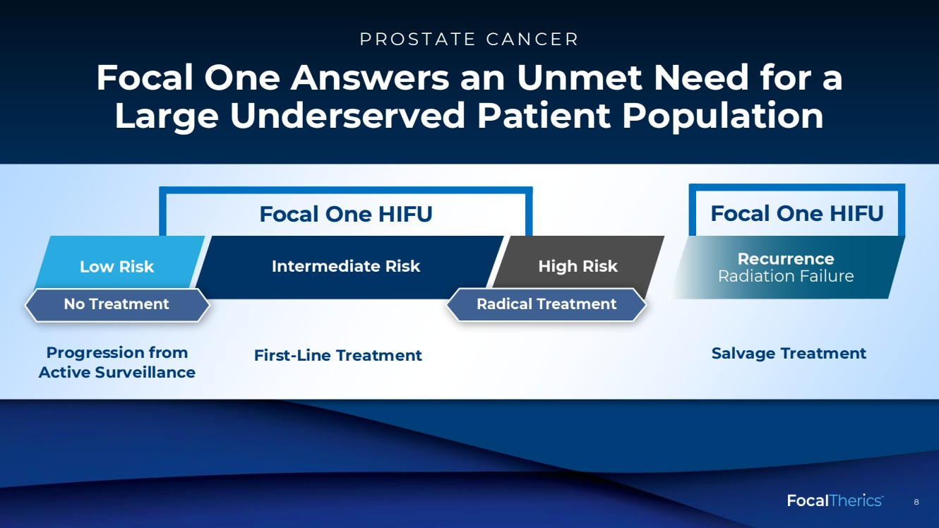 | 8 8 Focal One Answers an Unmet Need for a Large Underserved Patient Population PROSTATE CANCER Focal One HIFU Focal One HIFU
 | 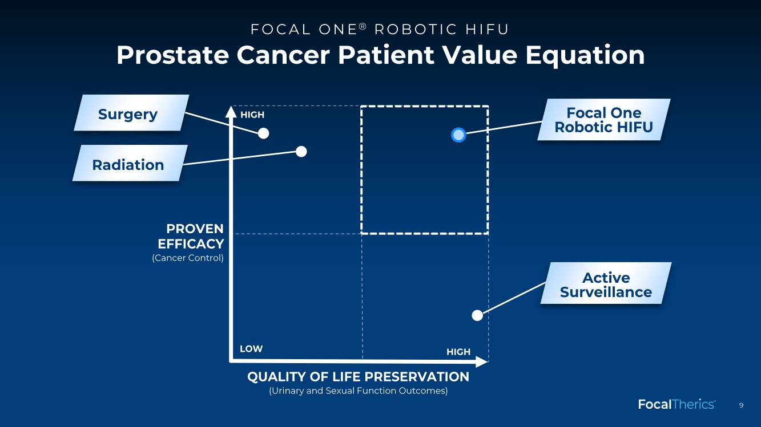 | 9 Prostate Cancer Patient Value Equation FOCAL ONE ® ROBOTIC HIFU PROVEN EFFICACY QUALITY OF LIFE PRESERVATION HIGH LOW HIGH Radiation (Urinary and Sexual Function Outcomes) Focal One Robotic HIFU Active Surveillance Surgery (Cancer Control)
 | 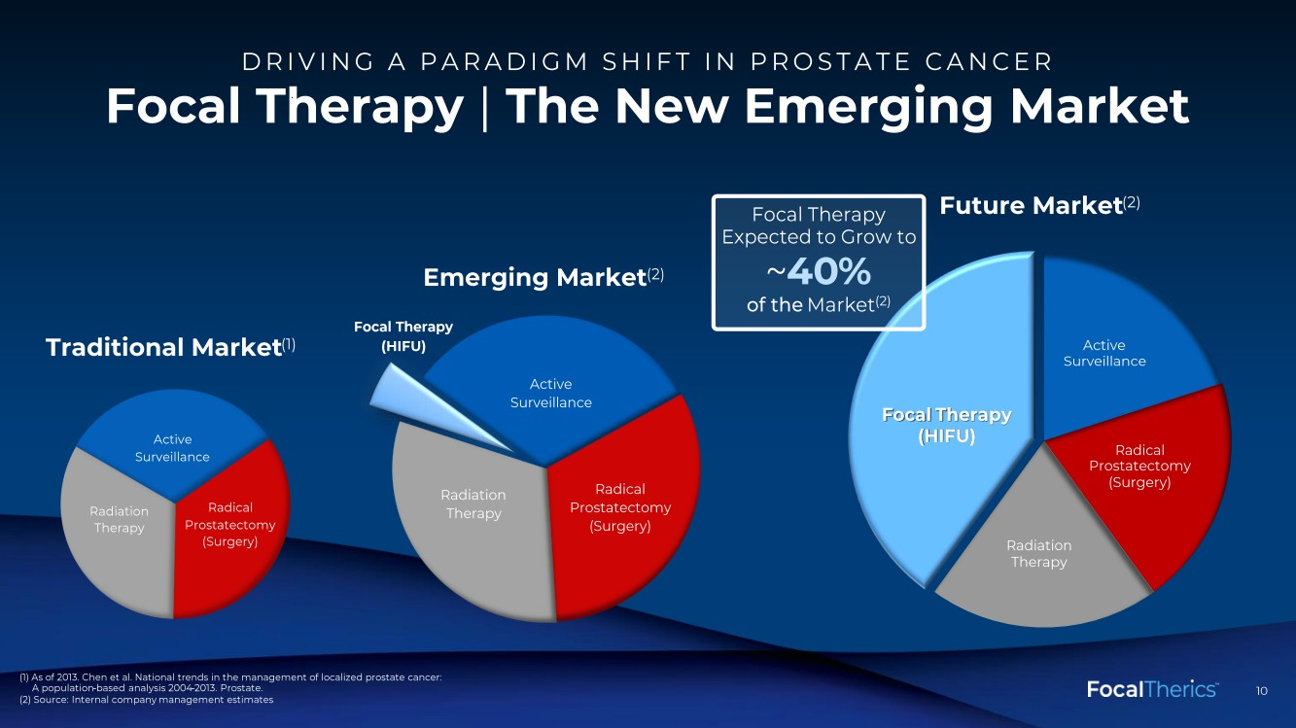 | 10 10 Focal Therapy |The New Emerging Market DRIVING A PARADIGM SHIFT IN PROSTATE CANCER (1) As of 2013. Chen et al. National trends in the management of localized prostate cancer: A population -based analysis 2004 -2013. Prostate. (2) Source: Internal company management estimates Active Surveillance Radical Prostatectomy (Surgery) Radiation Therapy Active Surveillance Radical Prostatectomy (Surgery) Radiation Therapy Focal Therapy Traditional Market (1) (HIFU) Emerging Market (2) Future Market (2) Active Surveillance Radical Prostatectomy (Surgery) Radiation Therapy Focal Therapy (HIFU) Focal Therapy Expected to Grow to ~40 % of the Market (2)
 | 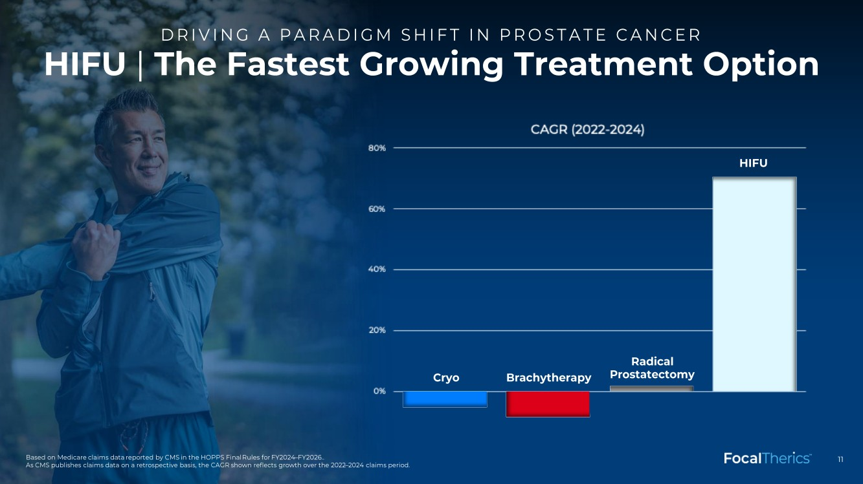 | 11 HIFU |The Fastest Growing Treatment Option DRIVING A PARADIGM SHIFT IN PROSTATE CANCER Based on Medicare claims data reported by CMS in the HOPPS Final Rules for FY2024 –FY2026.. As CMS publishes claims data on a retrospective basis, the CAGR shown reflects growth over the 2022 –2024 claims period. HIFU Cryo Brachytherapy Radical Prostatectomy
 | 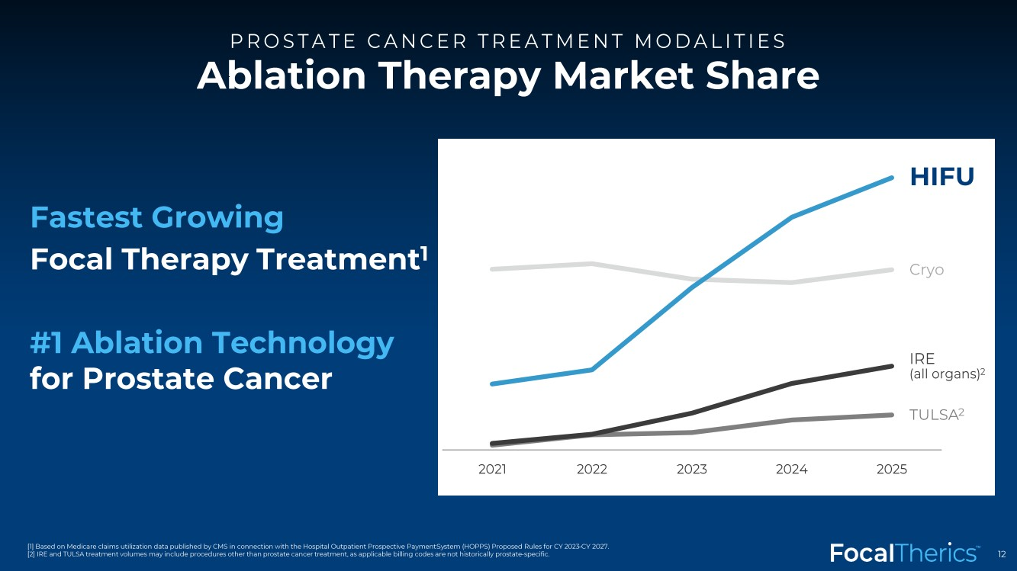 | 12 [1] Based on Medicare claims utilization data published by CMS in connection with the Hospital Outpatient Prospective Payment Sy stem (HOPPS) Proposed Rules for CY 2023 –CY 2027. [2] IRE and TULSA treatment volumes may include procedures other than prostate cancer treatment, as applicable billing codes are not historically prostate -specific. HIFU Cryo TULSA 2 2021 2022 2023 2024 2025 IRE (all organs) 2 Fastest Growing Focal Therapy Treatment 1 #1 Ablation Technology for Prostate Cancer Ablation Therapy Market Share PROSTATE CANCER TREATMENT MODALITIES
 |  | 13 Strong Supporting Clinical Evidence
 | 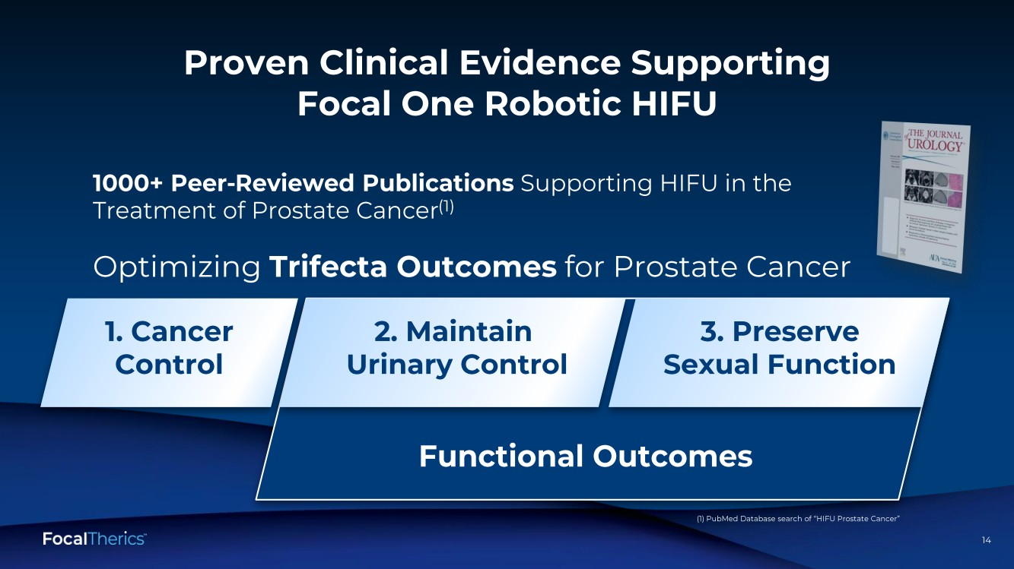 | 14 14 Proven Clinical Evidence Supporting Focal One Robotic HIFU 1000+ Peer -Reviewed Publications Supporting HIFU in the Treatment of Prostate Cancer (1) 3. Preserve Sexual Function 2. Maintain Urinary Control 1. Cancer Control Optimizing Trifecta Outcomes for Prostate Cancer (1) PubMed Database search of “HIFU Prostate Cancer” Functional Outcomes
 | 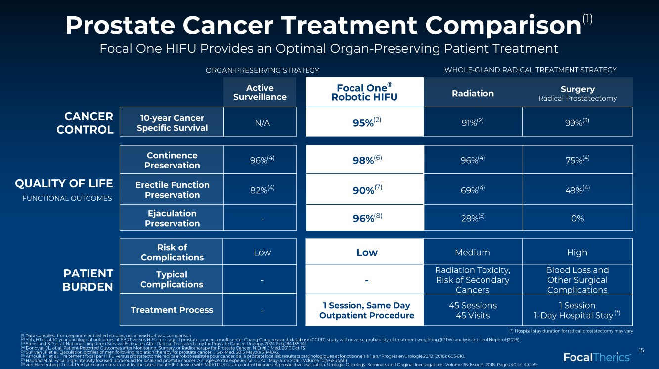 | 15 Low - 1 Session, Same Day Outpatient Procedure Focal One ® Robotic HIFU 95% (2) ORGAN -PRESERVING STRATEGY WHOLE -GLAND RADICAL TREATMENT STRATEGY CANCER CONTROL QUALITY OF LIFE PATIENT BURDEN Prostate Cancer Treatment Comparison (1) Focal One HIFU Provides an Optimal Organ -Preserving Patient Treatment FUNCTIONAL OUTCOMES Continence Preservation 96% (4) Erectile Function Preservation 82% (4) Ejaculation Preservation - Risk of Complications Low Typical Complications - Treatment Process - Active Surveillance 10-year Cancer Specific Survival N/A (*) Hospital stay duration for radical prostatectomy may vary (1) Data compiled from separate published studies; not a head -to -head comparison (2) Yeh, HT et al. 10-year oncological outcomes of EBRT versus HIFU for stage II prostate cancer: a multicenter Chang Gung research database (CGRD) study with inverse -probability -of-treatment weighting (IPTW) analysis. Int Urol Nephrol (2025). (3) Stensland KD et al. National Long -term Survival Estimates After Radical Prostatectomy for Prostate Cancer. Urology. 2024 Feb;18 4:135-141. (4) Donovan JL, et al. Patient -Reported Outcomes after Monitoring, Surgery, or Radiotherapy for Prostate Cancer. N Engl J Med. 2016 Oct 13. (5) Sullivan JF et al. Ejaculation profiles of men following radiation therapy for prostate cancer. J Sex Med. 2013 May;10(5):141 0 -6. (6) Arnouil , N., et al. " Traitement focal par HIFU versus prostatectomie radicale robot -assistée pour cancer de la prostate localisé : résultats carcinologiques et fonctionnels à 1 an." Progrès en Urologie 28.12 (2018): 603 -610. (7) Haddad et al. Focal high -intensity focused ultrasound for localized prostate cancer: A single -centre experience. CUAJ • May -June 2016 • Volume 10(5 -6Suppl1) (8) von Hardenberg J et al. Prostate cancer treatment by the latest focal HIFU device with MRI/TRUS -fusion control biopsies: A pros pective evaluation. Urologic Oncology: Seminars and Original Investigations, Volume 36, Issue 9, 2018, Pages 401.e1 -401.e9 98% (6) 90% (7) 96% (8) 96% (4) 75% (4) 69% (4) 49% (4) 28% (5) 0% Medium High Radiation Toxicity, Risk of Secondary Cancers Blood Loss and Other Surgical Complications 45 Sessions 45 Visits 1 Session 1-Day Hospital Stay (*) 91%(2) 99% (3) Radiation Surgery Radical Prostatectomy
 | 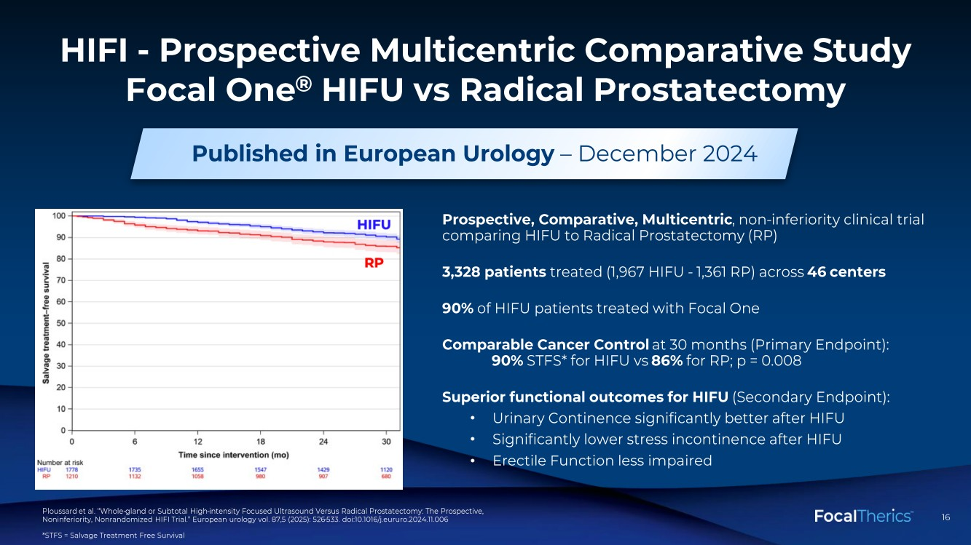 | 16 16 HIFI - Prospective Multicentric Comparative Study Focal One ® HIFU vs Radical Prostatectomy Prospective, Comparative, Multicentric , non -inferiority clinical trial comparing HIFU to Radical Prostatectomy (RP) 3,328 patients treated (1,967 HIFU - 1,361 RP) across 46 centers 90% of HIFU patients treated with Focal One Comparable Cancer Control at 30 months (Primary Endpoint): 90% STFS* for HIFU vs 86% for RP; p = 0.008 Superior functional outcomes for HIFU (Secondary Endpoint): • Urinary Continence significantly better after HIFU • Significantly lower stress incontinence after HIFU • Erectile Function less impaired Published in European Urology – December 2024 Ploussard et al. “Whole -gland or Subtotal High -intensity Focused Ultrasound Versus Radical Prostatectomy: The Prospective, Noninferiority, Nonrandomized HIFI Trial.” European urology vol. 87,5 (2025): 526 -533. doi:10.1016/j.eururo.2024.11.006 *STFS = Salvage Treatment Free Survival
 | 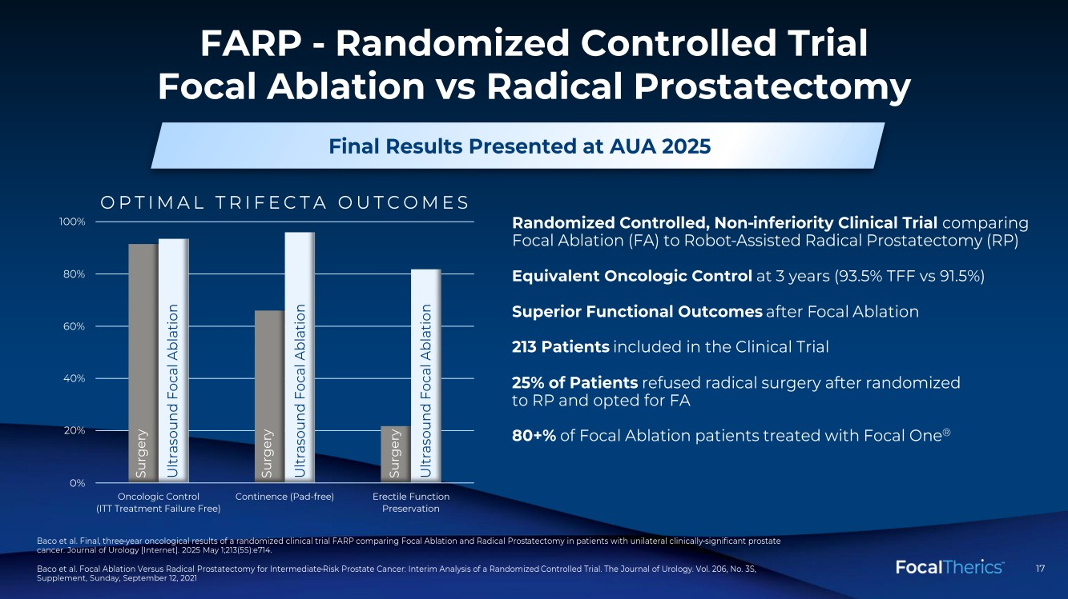 | 17 17 FARP - Randomized Controlled Trial Focal Ablation vs Radical Prostatectomy Randomized Controlled, Non -inferiority Clinical Trial comparing Focal Ablation (FA) to Robot -Assisted Radical Prostatectomy (RP) Equivalent Oncologic Control at 3 years (93.5% TFF vs 91.5%) Superior Functional Outcomes after F ocal Ablation 213 Patients included in the Clinical Trial 25% of Patients refused radical surgery after randomized to RP and opted for FA 80+% of Focal Ablation patients treated with Focal One ® Baco et al. Final, three -year oncological results of a randomized clinical trial FARP comparing Focal Ablation and Radical Prost atectomy in patients with unilateral clinically -significant prostate cancer. Journal of Urology [Internet]. 2025 May 1;213(5S):e714. Baco et al. Focal Ablation Versus Radical Prostatectomy for Intermediate -Risk Prostate Cancer: Interim Analysis of a Randomized Controlled Trial. The Journal of Urology. Vol. 206, No. 3S, Supplement, Sunday, September 12, 2021 Final Results Presented at AUA 2025 0% 20% 40% 60% 80% 100% Oncologic Control (ITT Treatment Failure Free) Continence (Pad-free) Erectile Function Preservation Surgery Ultrasound Focal Ablation Surgery Ultrasound Focal Ablation Surgery Ultrasound Focal Ablation OPTIMAL TRIFECTA OUTCOMES
 | 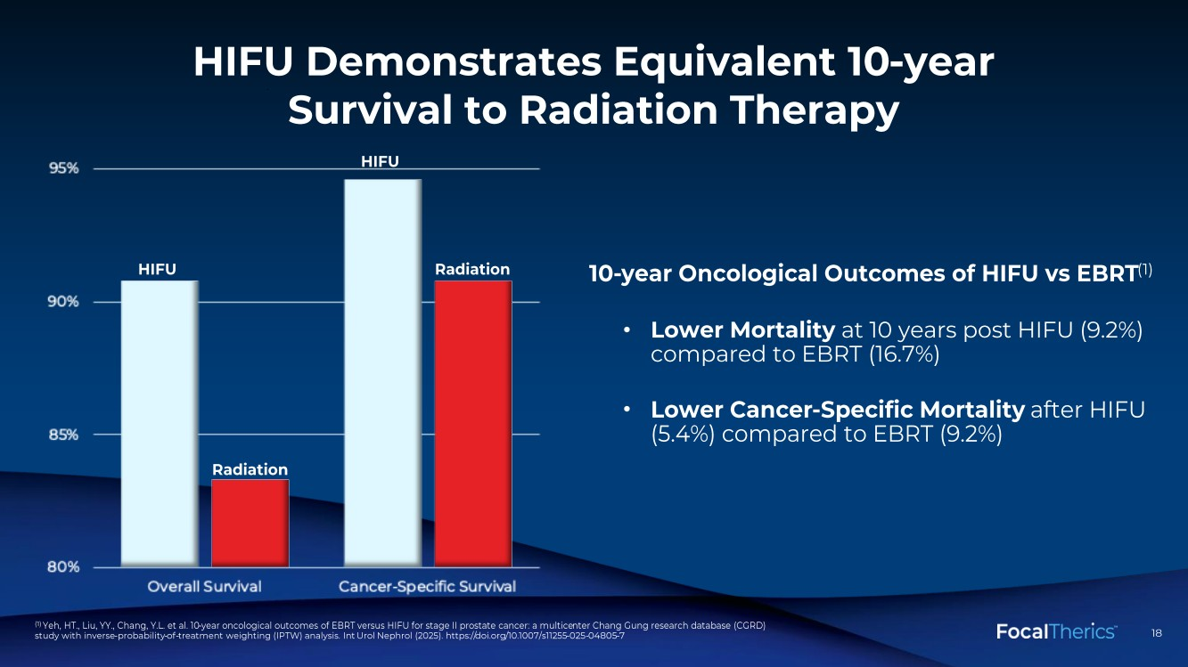 | 18 18 HIFU Demonstrates Equivalent 10 -year Survival to Radiation Therapy 10-year Oncological Outcomes of HIFU vs EBRT (1) • Lower Mortality at 10 years post HIFU (9.2%) compared to EBRT (16.7%) • Lower Cancer -Specific Mortality after HIFU (5.4%) compared to EBRT (9.2%) (1) Yeh, HT., Liu, YY., Chang, Y.L. et al. 10 -year oncological outcomes of EBRT versus HIFU for stage II prostate cancer: a multice nter Chang Gung research database (CGRD) study with inverse -probability -of-treatment weighting (IPTW) analysis. Int Urol Nephrol (2025). https:// doi.org /10.1007/s11255-025 -04805 -7 HIFU Radiation HIFU Radiation
 |  | 19 Strong Hospital and Physician Reimbursement
 | 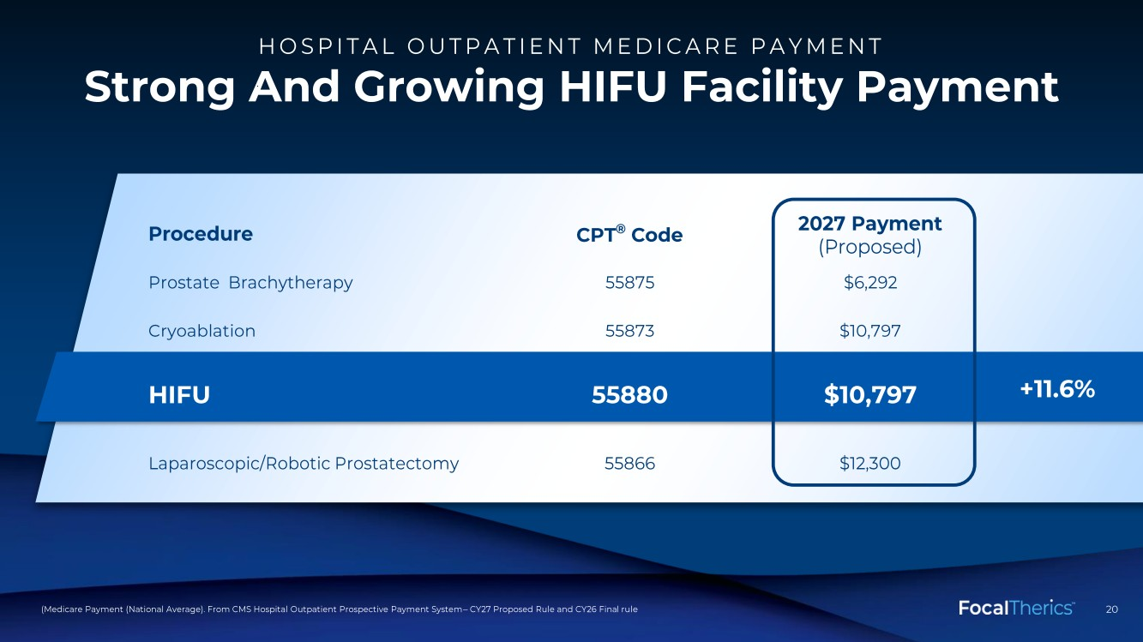 | 20 20 Strong And Growing HIFU Facility Payment (Medicare Payment (National Average). From CMS Hospital Outpatient Prospective Payment System – CY27 Proposed Rule and CY26 Fina l rule Procedure CPT ® Code 2027 Payment (Proposed) Prostate Brachytherapy 55875 $6,292 Cryoablation 55873 $10,797 HIFU 55880 $10,797 Laparoscopic/Robotic Prostatectomy 55866 $12,300 +11.6% HOSPITAL OUTPATIENT MEDICARE PAYMENT
 | 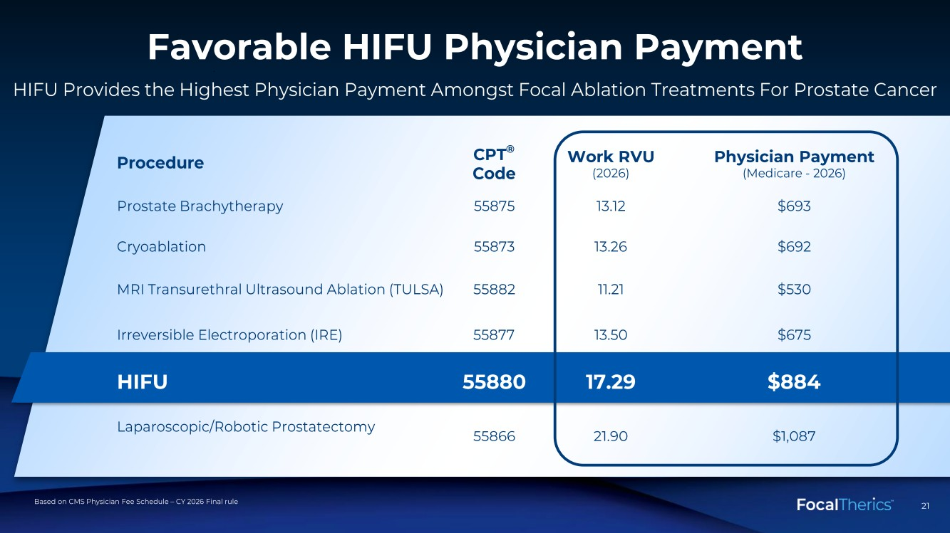 | 21 21 Favorable HIFU Physician Payment Based on CMS Physician Fee Schedule – CY 2026 Final rule Procedure CPT ® Code Work RVU (2026) Physician Payment (Medicare - 2026) Prostate Brachytherapy 55875 13.12 $693 Cryoablation 55873 13.26 $692 MRI Transurethral Ultrasound Ablation (TULSA) 55882 11.21 $530 Irreversible Electroporation (IRE) 55877 13.50 $675 HIFU 55880 17.29 $884 Laparoscopic/Robotic Prostatectomy 55866 21.90 $1,087 HIFU Provides the Highest Physician Payment Amongst Focal Ablation Treatments For Prostate Cancer
 |  | 22 Expanding Clinical Indications
 | 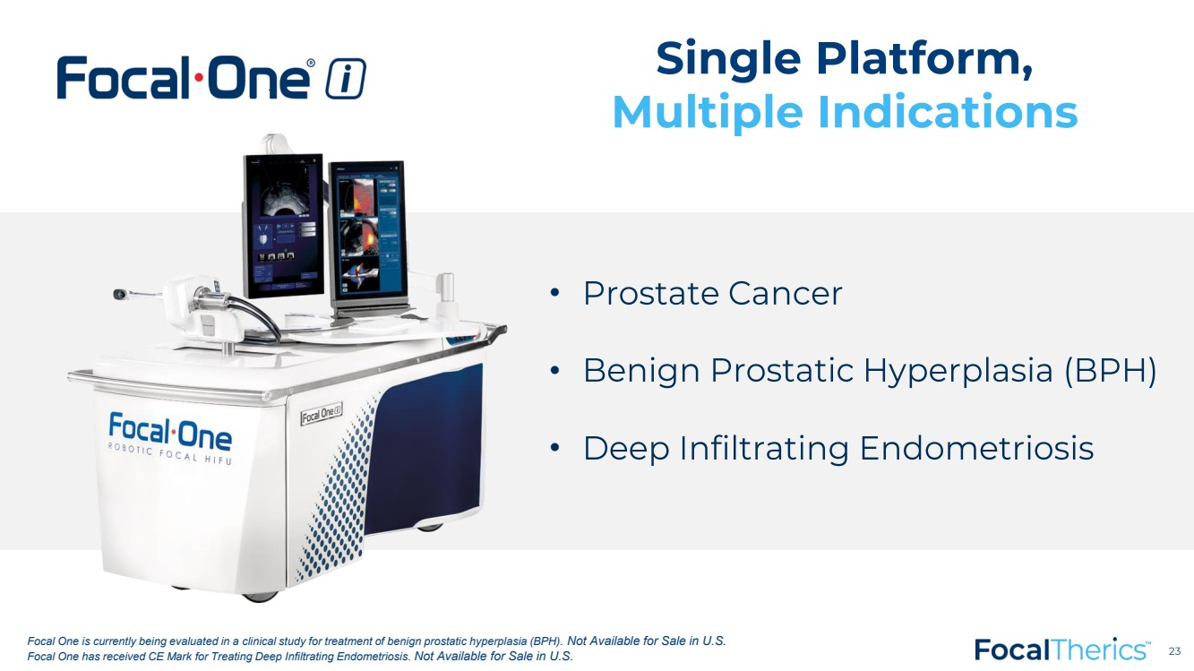 | 23 23 Single Platform, Multiple Indications • Prostate Cancer • Benign Prostatic Hyperplasia (BPH) • Deep Infiltrating Endometriosis Focal One is currently being evaluated in a clinical study for treatment of benign prostatic hyperplasia (BPH). Not Available for Sale in U.S. Focal One has received CE Mark for Treating Deep Infiltrating Endometriosis. Not Available for Sale in U.S.
 | 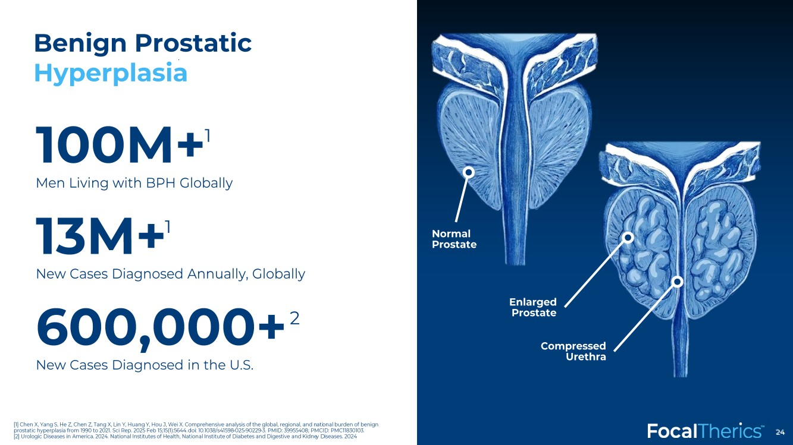 | 24 Benign Prostatic Hyperplasia 24 Normal Prostate Compressed Urethra Enlarged Prostate 100M+ Men Living with BPH Globally 13M+ New Cases Diagnosed Annually, Globally 600,000+ New Cases Diagnosed in the U.S. [1] Chen X, Yang S, He Z, Chen Z, Tang X, Lin Y, Huang Y, Hou J, Wei X. Comprehensive analysis of the global, regional, and n ati onal burden of benign prostatic hyperplasia from 1990 to 2021. Sci Rep. 2025 Feb 15;15(1):5644. doi : 10.1038/s41598 -025 -90229 -3. PMID: 39955408; PMCID: PMC11830103. [2] Urologic Diseases in America. 2024. National Institutes of Health, National Institute of Diabetes and Digestive and Kidne y D iseases. 2024 1 1 2
 | 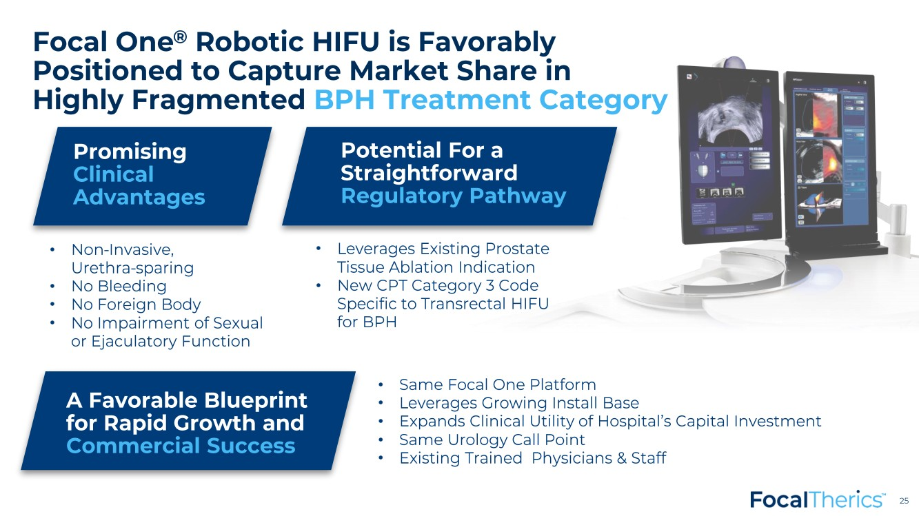 | 25 25 • Non -Invasive, Urethra -sparing • No Bleeding • No Foreign Body • No Impairment of Sexual or Ejaculatory Function Promising Clinical Advantages • Leverages Existing Prostate Tissue Ablation Indication • New CPT Category 3 Code Specific to Transrectal HIFU for BPH Potential For a Straightforward Regulatory Pathway • Same Focal One Platform • Leverages Growing Install Base • Expands Clinical Utility of Hospital’s Capital Investment • Same Urology Call Point • Existing Trained Physicians & Staff A Favorable Blueprint for Rapid Growth and Commercial Success Focal One ® Robotic HIFU is Favorably Positioned to Capture Market Share in Highly Fragmented BPH Treatment Category
 | 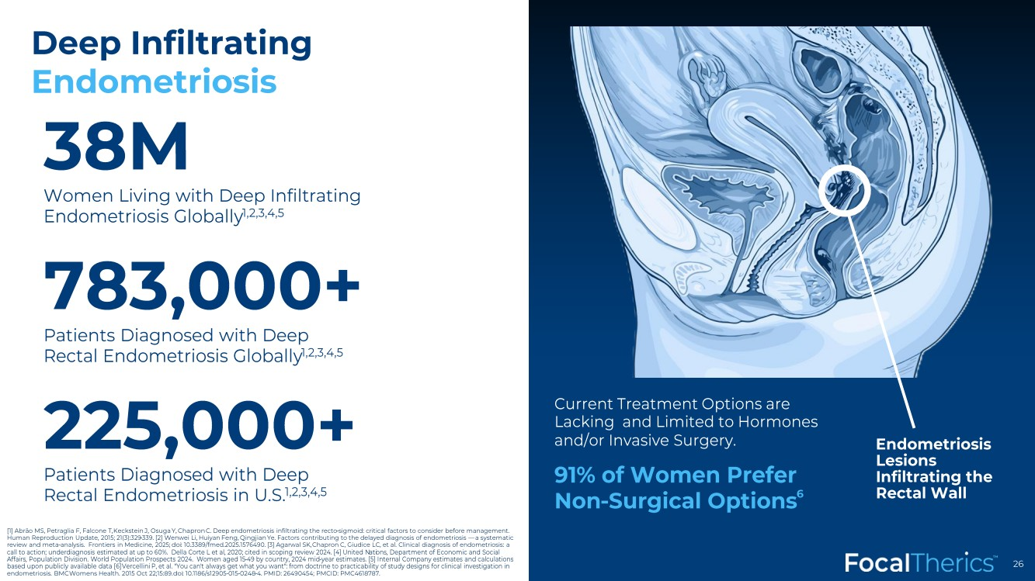 | 26 Deep Infiltrating Endometriosis Endometriosis Lesions Infiltrating the Rectal Wall 38M Women Living with Deep Infiltrating Endometriosis Globally 1,2,3,4,5 783,000+ Patients Diagnosed with Deep Rectal Endometriosis Globally 1,2,3,4,5 225,000+ Patients Diagnosed with Deep Rectal Endometriosis in U.S. 1,2,3,4,5 Current Treatment Options are Lacking and Limited to Hormones and/or Invasive Surgery. 91% of Women Prefer Non -Surgical Options 6 [1] Abrão MS, Petraglia F, Falcone T, Keckstein J, Osuga Y, Chapron C. Deep endometriosis infiltrating the recto -sigmoid: critical factors to consider before management. Human Reproduction Update, 2015; 21(3):329 -339. [2] Wenwei Li, Huiyan Feng, Qingjian Ye. Factors contributing to the delayed diagnosis of endometriosis — a systematic review and meta -analysis. Frontiers in Medicine, 2025; doi : 10.3389/fmed.2025.1576490. [3] Agarwal SK, Chapron C, Giudice LC, et al. Clinical diagnosis of endometriosis: a call to action; underdiagnosis estimated at up to 60%. Della Corte L et al, 2020; cited in scoping review 2024. [4] United N ati ons, Department of Economic and Social Affairs, Population Division. World Population Prospects 2024. Women aged 15 -49 by country, 2024 mid -year estimates. [5] Intern al Company estimates and calculations based upon publicly available data [6] Vercellini P, et al. "You can't always get what you want": from doctrine to practicability of study designs for clinical investigation i n endometriosis. BMC Womens Health. 2015 Oct 22;15:89. doi : 10.1186/s12905 -015-0248 -4. PMID: 26490454; PMCID: PMC4618787.
 | 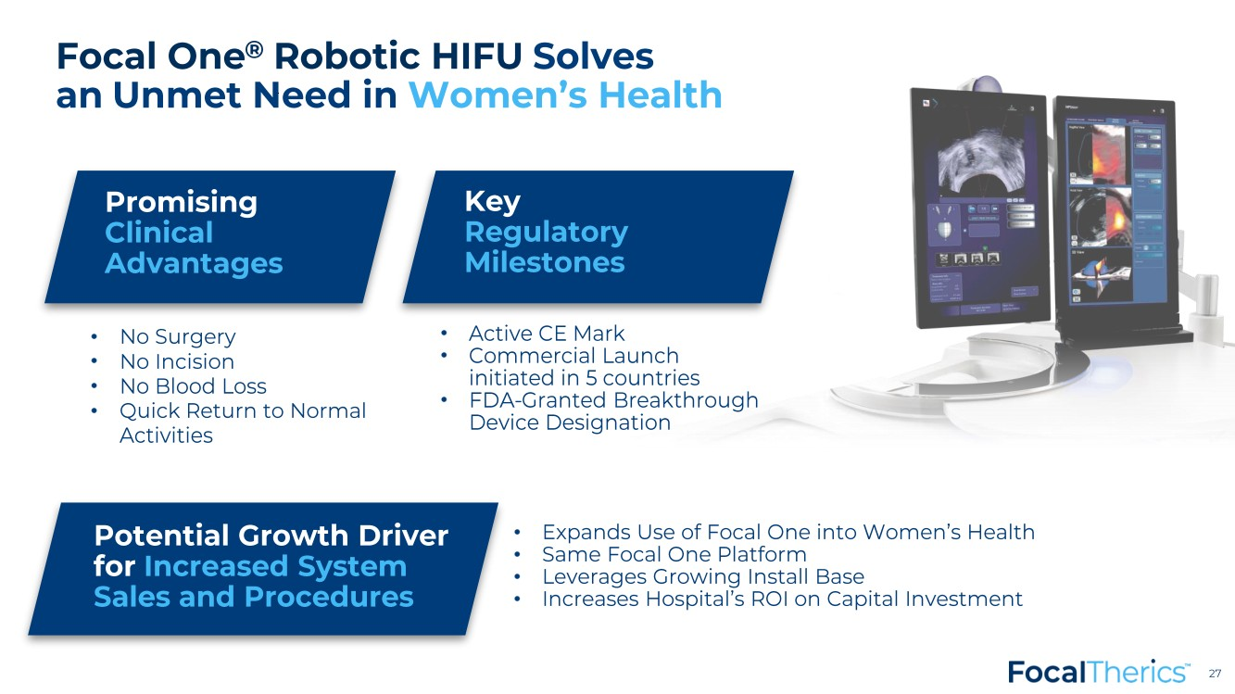 | 27 27 • No Surgery • No Incision • No Blood Loss • Quick Return to Normal Activities Promising Clinical Advantages • Active CE Mark • Commercial Launch initiated in 5 countries • FDA -Granted Breakthrough Device Designation Key Regulatory Milestones • Expands Use of Focal One into Women’s Health • Same Focal One Platform • Leverages Growing Install Base • Increases Hospital’s ROI on Capital Investment Potential Growth Driver for Increased System Sales and Procedures Focal One ® Robotic HIFU Solves an Unmet Need in Women’s Health
 | 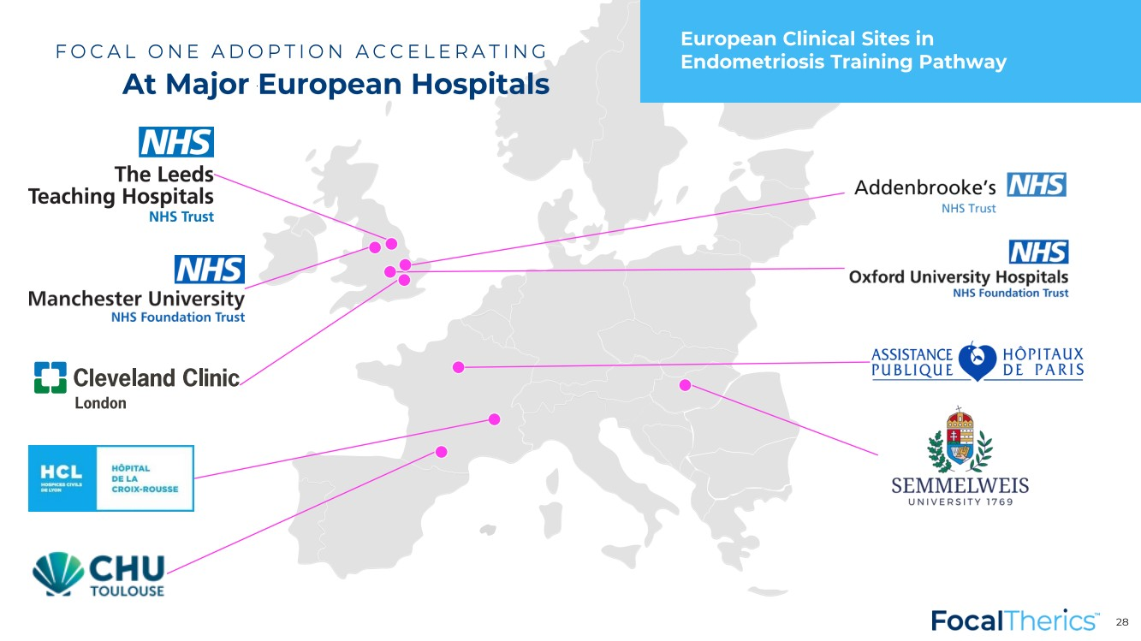 | FOCAL ONE ADOPTION ACCELERATING At Major European Hospitals 28 European Clinical Sites in Endometriosis Training Pathway
 |  | 29 Technology Leadership & Innovation
 | 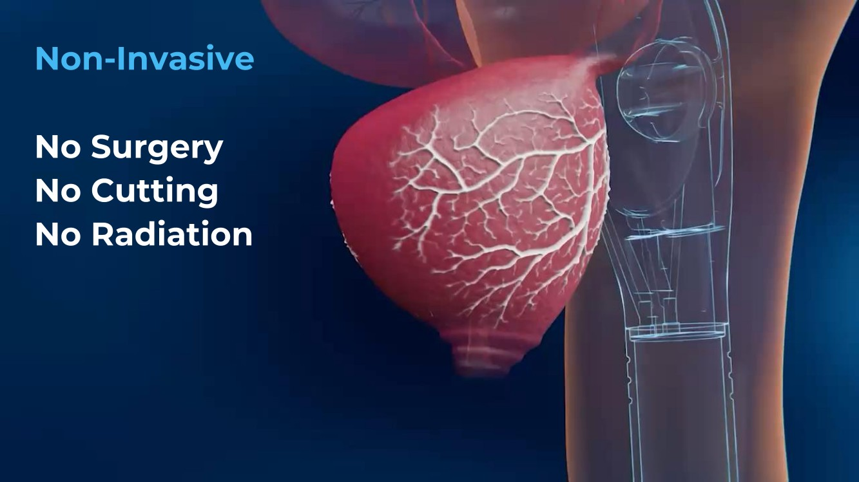 | 30 Non -Invasive No Surgery No Cutting No Radiation
 | 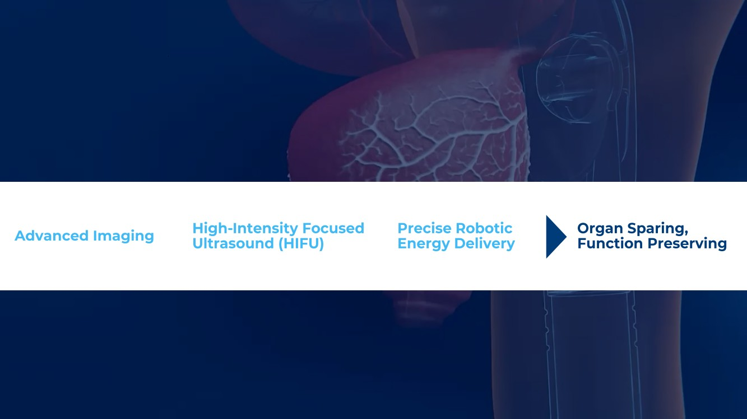 | 31 High -Intensity Focused Ultrasound (HIFU) Advanced Imaging Precise Robotic Energy Delivery Organ Sparing, Function Preserving
 | 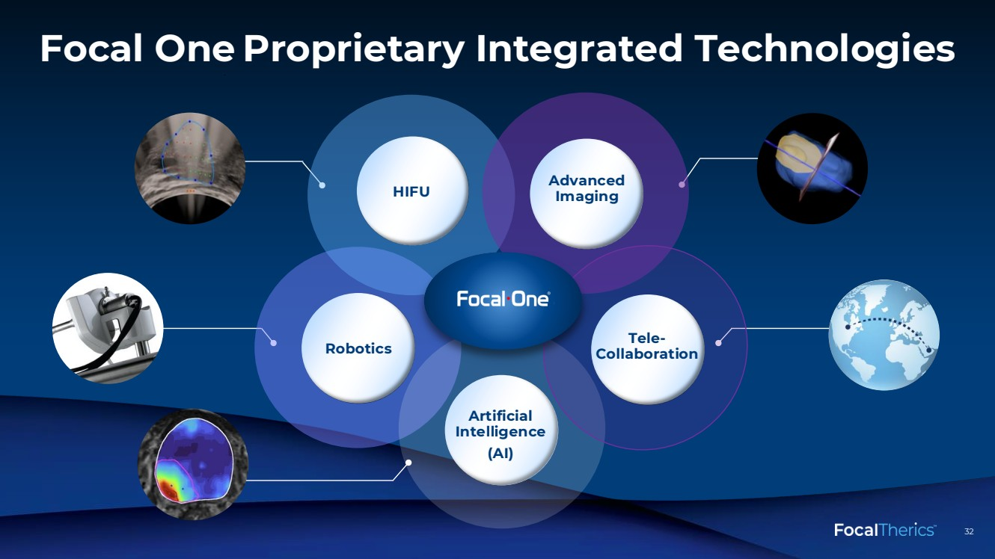 | 32 32 Focal One Proprietary Integrated Technologies Robotics Advanced Imaging Artificial Intelligence (AI) Tele - Collaboration
 | 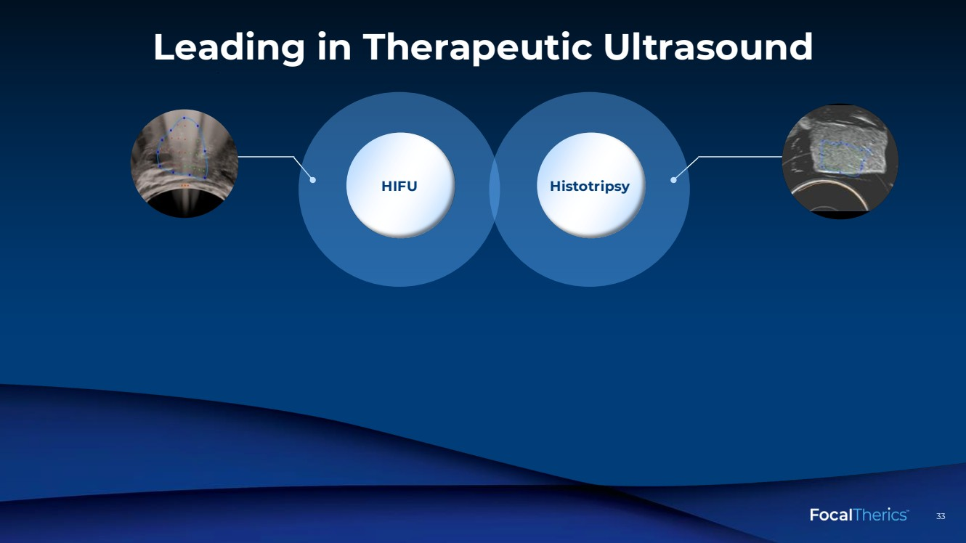 | 33 33 Leading in Therapeutic Ultrasound
 | 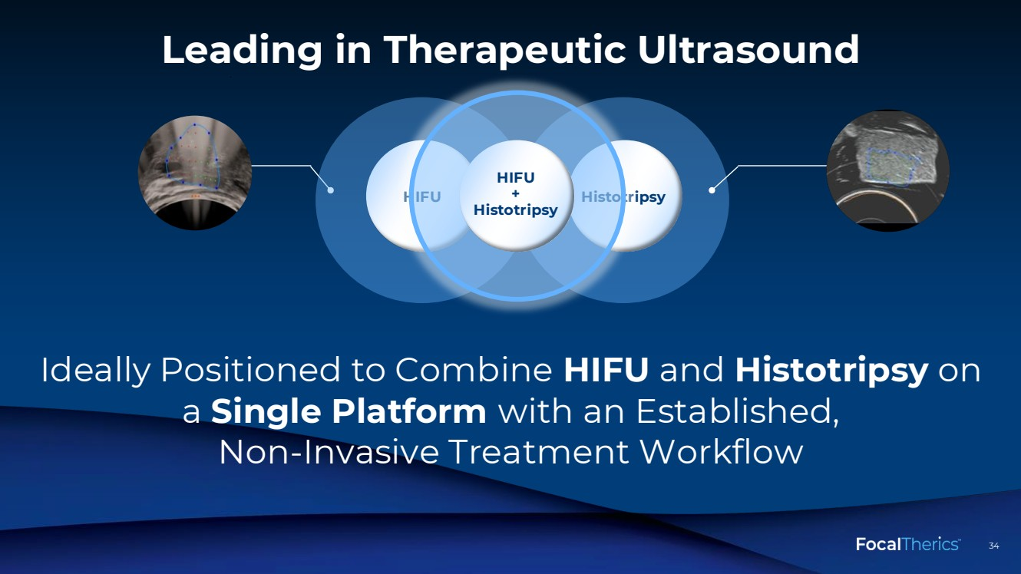 | 34 34 Leading in Therapeutic Ultrasound HIFU + Histotripsy Ideally Positioned to Combine HIFU and Histotripsy on a Single Platform with an Established, Non -Invasive Treatment Workflow
 | 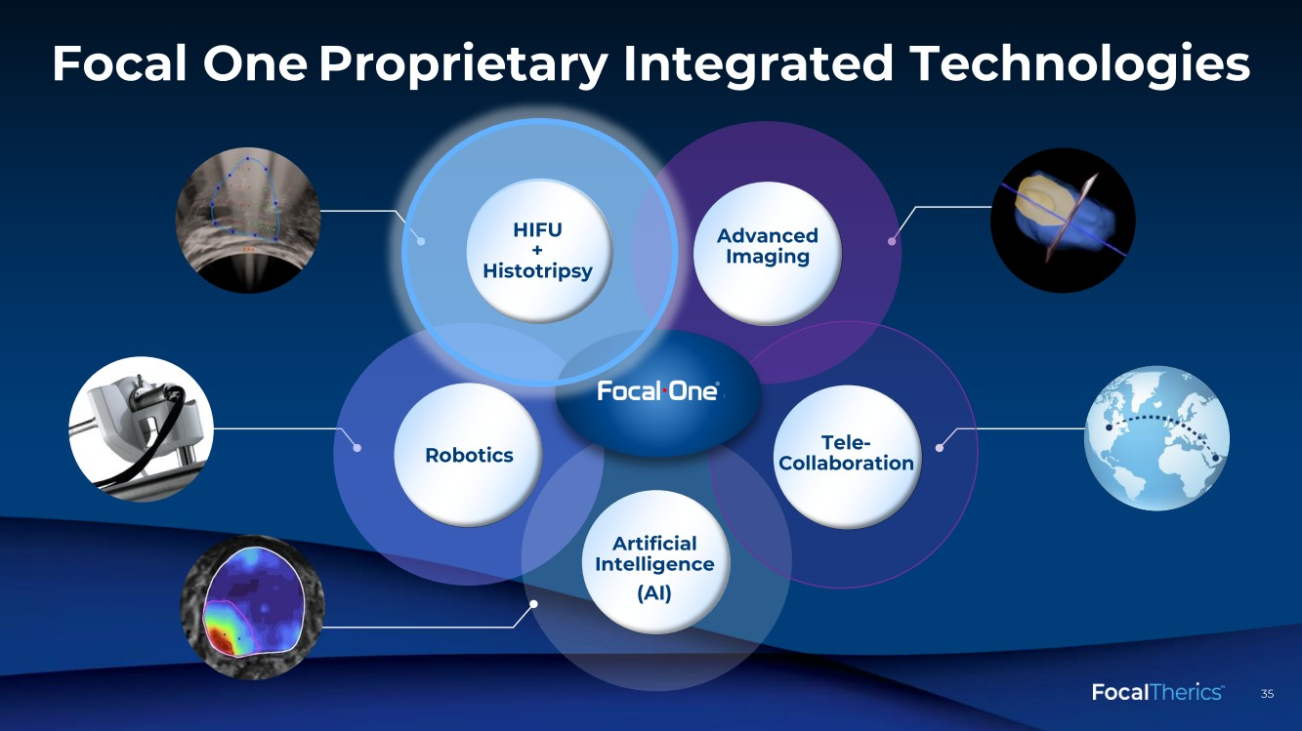 | 35 35 Focal One Proprietary Integrated Technologies Robotics HIFU Advanced Imaging Artificial Intelligence (AI) Tele - Collaboration HIFU + Histotripsy
 |  | 36 Accelerating Global Focal One Adoption
 | 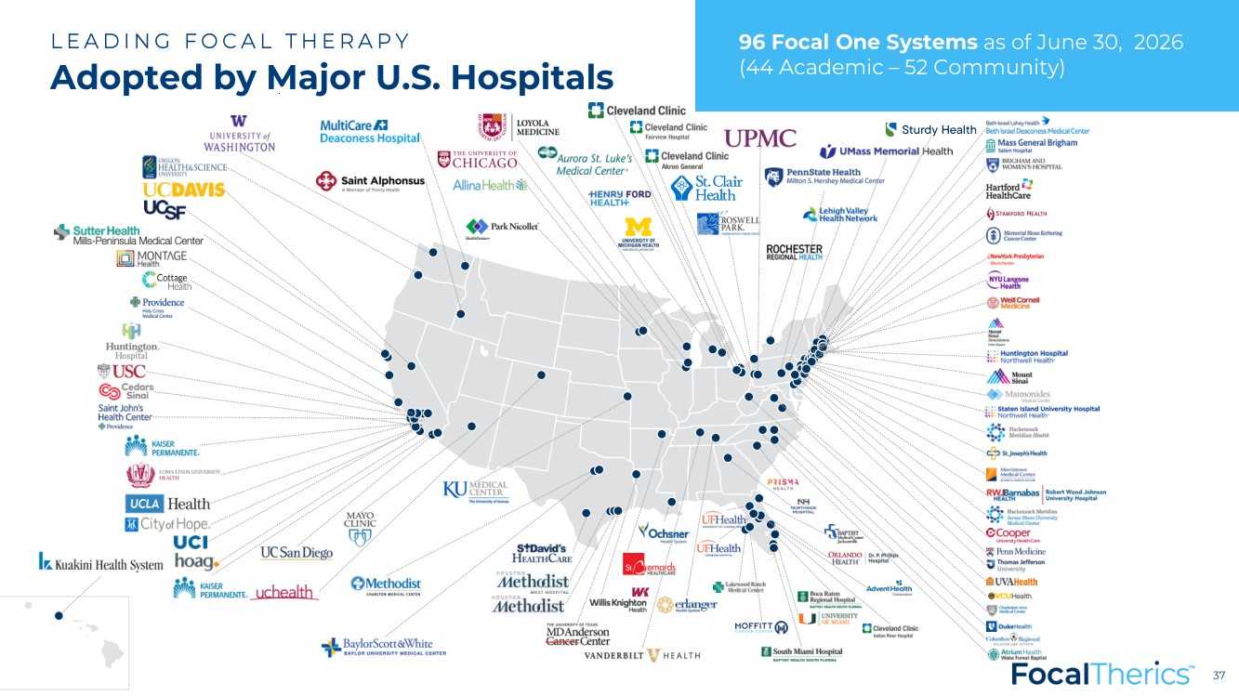 | 37 37 LEADING FOCAL THERAPY Adopted by Major U.S. Hospitals 96 Focal One Systems as of June 30, 2026 (44 Academic – 52 Community)
 | 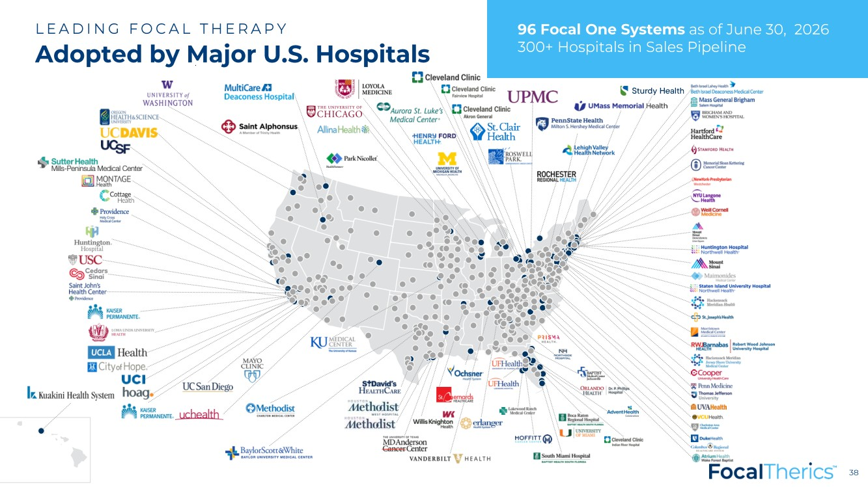 | 38 38 LEADING FOCAL THERAPY Adopted by Major U.S. Hospitals 96 Focal One Systems as of June 30, 2026 300+ Hospitals in Sales Pipeline
 | 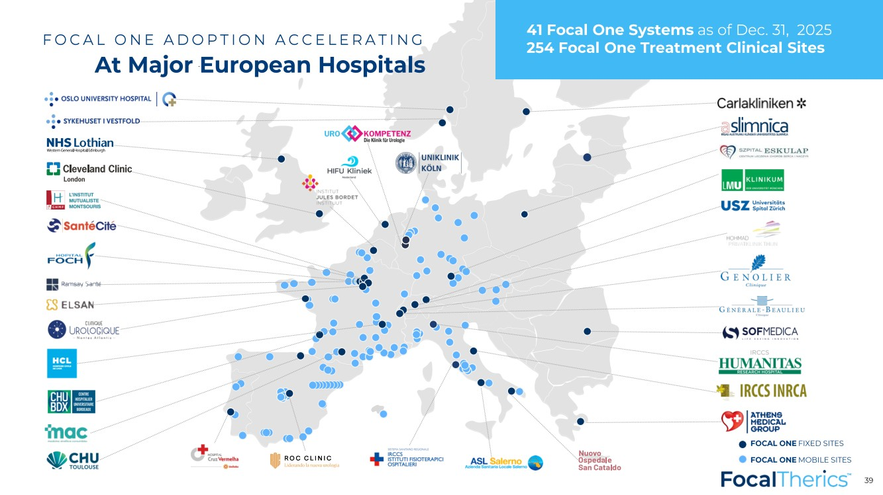 | FOCAL ONE MOBILE SITES FOCAL ONE FIXED SITES FOCAL ONE ADOPTION ACCELERATING At Major European Hospitals 39 41 Focal One Systems as of Dec. 31, 2025 254 Focal One Treatment Clinical Sites
 |  | 40 Company Highlights
 | 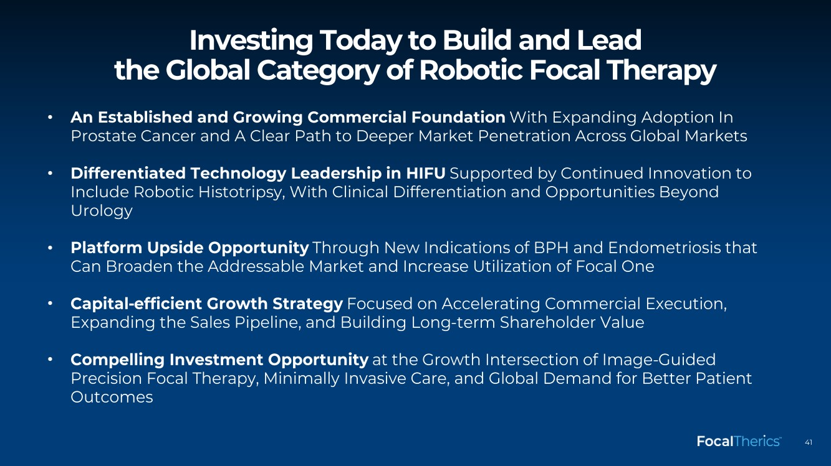 | 41 • An Established and Growing Commercial Foundation With Expanding Adoption In Prostate Cancer and A Clear Path to Deeper Market Penetration Across Global Markets • Differentiated Technology Leadership in HIFU Supported by Continued Innovation to Include Robotic Histotripsy, With Clinical Differentiation and Opportunities Beyond Urology • Platform Upside Opportunity Through New Indications of BPH and Endometriosis that Can Broaden the Addressable Market and Increase Utilization of Focal One • Capital -efficient Growth Strategy Focused on Accelerating Commercial Execution, Expanding the Sales Pipeline, and Building Long -term Shareholder Value • Compelling Investment Opportunity at the Growth Intersection of Image -Guided Precision Focal Therapy, Minimally Invasive Care, and Global Demand for Better Patient Outcomes Investing Today to Build and Lead the Global Category of Robotic Focal Therapy
 |  | 42 Annex
 | 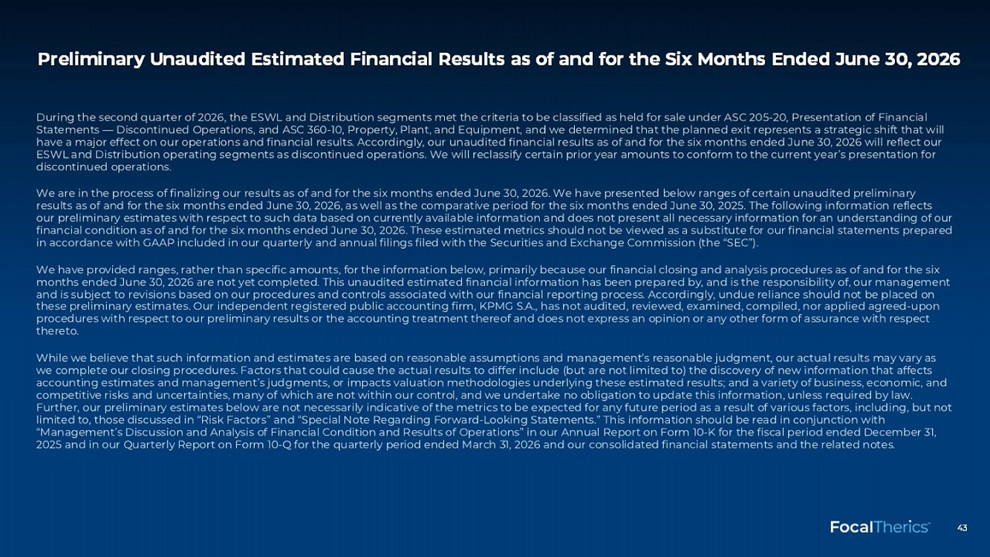 | 43 Preliminary Unaudited Estimated Financial Results as of and for the Six Months Ended June 30, 2026
 | 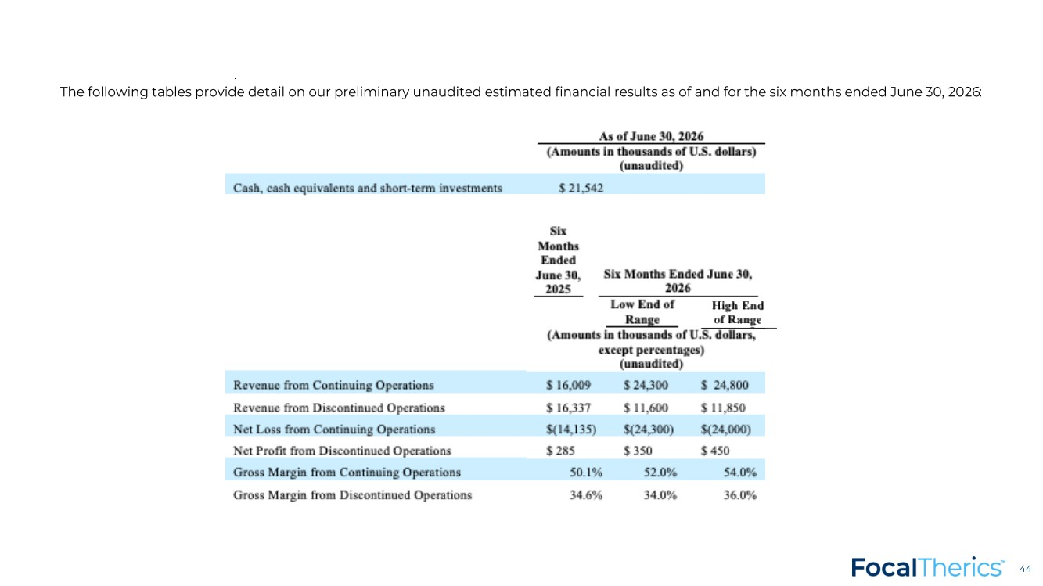 | 44 44 The following tables provide detail on our preliminary unaudited estimated financial results as of and for the six months ended June 30, 2026 :
 |  | 45 Global Leader in Therapeutic Ultrasound

